

STOCK ANALYSIS
UnitedHealth Group Inc.
UNH | NYSE
2026-06-05

DATA RELIABILITY LEGEND
+17% | Green = positive figure, directly from company filings
-3% | Red = negative figure, directly from company filings
12.5% | Underlined = analyst-computed or estimated (not from company filings)
0% | Black = zero or neutral / non-numerical text

CHART COLOR PALETTE — Use only these colors in all charts
#F2E4B7 | #F6EDC9 | #FCF5DB | #F1EAB7 | #ECE09D
#990013 | #890013 | #7a013e | #6b013c | #5b013a

Table of Contents

Note: Right-click on the Table of Contents and select “Update Field” to refresh page numbers and links after editing the report.

Section 1 — Business Overview, Operations & Competitive Positioning
---

1.1 The Business
UnitedHealth Group is a health care and well-being company organized under two complementary platforms — UnitedHealthcare, which provides health benefits and insurance products across employer-sponsored, individual, Medicare, and Medicaid markets, and Optum, an information- and technology-enabled health services business encompassing care delivery, pharmacy benefits management, and data analytics. The company generates revenue primarily through premiums on risk-based health benefit products (nearly 80% of consolidated revenues), pharmacy product sales, and fees for technology, analytics, care delivery, and administrative services.
UNH is the largest diversified managed care company in the United States, serving approximately 49.8 million people through UnitedHealthcare medical products and approximately 95 million consumers through Optum Health. The business model is built on the integration of payer and services capabilities: UnitedHealthcare provides the insurance chassis and member base, while Optum delivers care, manages pharmacy benefits, and provides data and analytics infrastructure. A large and growing share of intercompany revenue — $168.0 billion in FY2025 — flows from UnitedHealthcare to Optum segments. The company had more than 390,000 employees as of year-end, including nearly 165,000 clinical professionals.
FY2025 was a year of severe operational stress. Revenue grew 11.8% to $447,567M, but profitability collapsed: EBIT fell 41.3% to $18,964M, net income declined 16.3% to $12,056M, and diluted EPS fell to $13.23 from $15.51. The medical care ratio surged to 89.1%, and Optum Health swung to an operating loss. A near-complete C-suite overhaul — including the return of Stephen Hemsley as CEO and the hiring of Wayne DeVeydt as CFO — added governance uncertainty to an already challenging operating backdrop.
Key Information
Item | Value
Ticker | UNH (NYSE)
Sector / Industry | Health Care / Managed Care
FY2025 Revenue | $447,567M
FY2025 EBIT Margin | 4.24%
FY2025 Diluted EPS | $13.23
Diluted Shares Outstanding | 911M
---

1.2 Operating Segments
UNH reports four operating segments: UnitedHealthcare (the health benefits platform) and three Optum segments — Optum Health (care delivery), Optum Insight (data analytics and technology), and Optum Rx (pharmacy benefits). Intersegment eliminations of $168.0 billion reflect the extensive intercompany revenue flows between UnitedHealthcare and the Optum segments.
FY2025 Segment Overview
Segment | Revenue ($M) | EBIT ($M) | EBIT Margin
UnitedHealthcare | 344,903 | 9,425 | 2.7%
Optum Health | 101,957 | (278) | (0.3%)
Optum Insight | 19,417 | 2,624 | 13.5%
Optum Rx | 154,726 | 7,193 | 4.6%
Eliminations | (173,436) | — | —
Consolidated | 447,567 | 18,964 | 4.2%
Source: UNH 10-K FY2025; Excel workbook UNH_Portfolio.xlsx, Data sheet.*

UnitedHealthcare
UnitedHealthcare is the health benefits arm, offering coverage products across employer-sponsored, individual, Medicare, and Medicaid markets. It operates through three sub-segments: Employer & Individual (29.7 million people), Medicare & Retirement (8.4 million Medicare Advantage, 4.3 million Medicare Supplement, 10.4 million Medicare Part D), and Community & State (nearly 7.4 million people across 32 states and DC). Revenue is generated through risk-based premiums (fixed monthly premium per member, with UNH assuming medical and administrative cost risk) and fee-based administrative services.
FY2025 revenue of $344,903M grew substantially, driven by Medicare and Medicaid premium increases. However, earnings from operations of $9,425M declined sharply as the medical care ratio surged to 89.1% from 85.5% in FY2024 (as flagged in F001). The company explicitly stated that "pricing trends and patient and member health status assumptions were well-short of the medical cost trends incurred." Premium revenues from CMS — covering Medicare Advantage, Part D, and related programs — represented 44% of total consolidated revenues, making CMS the single most important counterparty in UNH's business model.
UnitedHealthcare Employer & Individual Global revenue declined, reflecting the strategic exit from international markets: the Brazil operations were sold in 2024 (recording a $7.1 billion loss), and an agreement to sell remaining South American operations was entered into in Q4 2025. The company expects Medicare Advantage membership to contract in 2026, and Medicaid membership losses due to reduced eligibility and exit from one state.

Optum Health
Optum Health delivers comprehensive, patient-centered care through clinical sites, in-home, and virtual settings. Services include primary, specialty, and surgical care; chronic and behavioral health management; telehealth and remote patient monitoring; and health care financial services through Optum Financial/Optum Bank. Optum Health serves approximately 95 million consumers and more than 100 health payer partners.
FY2025 was a catastrophic year for Optum Health. The segment swung from $7,842M in operating income in FY2024 to an operating loss of $(278)M — an $8.1 billion year-over-year decline (as flagged in F005). Revenue of $101,957M grew, but operating margin collapsed from +7.4% to -0.3%. The drivers were: Medicare Advantage funding reductions, elevated medical cost trends in value-based care arrangements, the profile of newly added patients under value-based care, $1.7 billion in restructuring and other actions (including a $623 million loss contract reserve for anticipated 2026 losses), losses on portfolio divestitures, and reduced investment income. People served declined from 100 million to 95 million.
This is a critical finding. Optum Health is the centerpiece of UNH's vertical integration strategy. Its collapse into a loss-making position in a single year signals fundamental problems with value-based care economics: when Medicare Advantage rates are cut and medical costs rise faster than pricing assumptions, the value-based care model can produce losses rather than savings. Effective January 1, 2026, Optum Financial (including Optum Bank) was realigned from Optum Health to Optum Insight, which will change future segment comparability.

Optum Insight
Optum Insight connects the health care system with data analytics, technology platforms, and managed services for clinical, administrative, and financial processes. It serves hospital systems, physicians, health plans, state governments, and life sciences companies. Key capabilities include revenue cycle management, payment integrity, population health analytics, and core operating system modernization.
FY2025 revenue was $19,417M with operating income of $2,624M (13.5% margin). Optum Insight was the strongest-margin segment. However, the segment absorbed material cyberattack-related charges: the company increased reserves for Change Healthcare provider loan collections by $799 million in Q4 2025 (as flagged in F006). Aggregate backlog was approximately $31.1 billion as of December 31, 2025, of which $18.3 billion is expected to be realized within 12 months. Notably, $12.9 billion of the backlog relates to affiliated (intercompany) agreements, meaning the "external" backlog is approximately $18.2 billion. Backlog declined from $32.8 billion year-over-year.

Optum Rx
Optum Rx provides pharmacy care services through a network of approximately 64,000 retail pharmacies, home delivery, specialty and community health pharmacies, and infusion services. It also manages pharmacy benefits for health plans, employers, unions, and public-sector entities.
Optum Rx was the strongest-performing segment in FY2025. Revenue of $154,726M grew year-over-year, and operating income of $7,193M increased, driven by higher script volumes (1,659 million adjusted scripts in 2025 vs. 1,623 million in 2024), new client wins, and a net gain from the deconsolidation of a business. The segment recorded a net gain of $1.5 billion from portfolio divestitures in FY2025, including a $1.7 billion gain on deconsolidation. However, the Inflation Reduction Act altered the Medicare Part D model, shifting more risk to plans, and PBM regulation remains an escalating risk factor at both federal and state levels.
---

1.3 Geographic Exposure
UNH is overwhelmingly a domestic U.S. business. The company participates primarily in U.S. health markets, where health care spending accounted for 19% of GDP in 2025. An estimated 98.5% of revenue is generated domestically.
International operations are being wound down. The Brazil operations were sold in 2024 (recording a $7.1 billion loss including $4.1 billion of cumulative foreign currency translation losses). In Q4 2025, UNH agreed to sell its remaining South American operations, expected to close in H2 2026. Foreign pre-tax income was negative $196 million in FY2025.
Despite the domestic revenue concentration, there is a notable foreign tax footprint: foreign taxes paid were $2.2 billion (27% of total taxes paid), comprised primarily of taxes paid to Ireland, suggesting significant Optum operations or intellectual property domiciled there. This is relevant to the effective tax rate discussion in Section 2 (F008).
Currency exposure is minimal and declining. With the South American exit, remaining translation gains and losses flow through other comprehensive income but are not material to consolidated results. The company's functional currency is the U.S. dollar.
---

1.4 Management Team
The executive team underwent a near-complete overhaul in 2025, a major governance event for a company of this scale.
Stephen Hemsley (age 73) resumed the role of Chairman and CEO in May 2025. Hemsley had previously served as CEO from 2006 to 2017 and as Executive Chairman from 2017 to 2019, before becoming Non-Executive Chairman in November 2019. His return represents a "comeback CEO" scenario — unusual for a company of UNH's size and complexity. The filing does not specify the circumstances of former CEO Andrew Witty's departure, though the exhibit index includes specific stock option and restricted stock unit agreements for Witty, suggesting negotiated departure terms. The leadership transition occurred in the aftermath of the December 2024 shooting of UnitedHealthcare CEO Brian Thompson and amid the DOJ investigation and Change Healthcare cyberattack aftermath.
Wayne DeVeydt (age 56) joined as CFO in September 2025 from Bain Capital, where he had been Managing Director. DeVeydt previously served as CFO of Elevance Health (formerly Anthem) from 2007 to 2016. His arrival from outside the company — and from a competitor — signals a leadership reset. The fact that UNH's new CFO set accounting estimates and reserves for the first time in Q4 2025, when $2.5 billion in restructuring charges were taken, is contextually important (as flagged in F003).
Dr. Patrick Conway (age 51) was elevated to CEO of Optum in May 2025. Conway had previously led Optum Rx and Optum Health Care Solutions and previously served as CMS Chief Medical Officer and acting administrator. Timothy Noel (age 54) became CEO of UnitedHealthcare in January 2025. Chris Zaetta (age 54) serves as Chief Legal Officer since May 2024. Tom Roos (age 53) continues as Chief Accounting Officer since 2015.
The structural implication of this overhaul is significant. A wholesale leadership change at a $448 billion revenue company creates execution risk, particularly when the incoming team faces simultaneous challenges: margin compression, regulatory headwinds, a major DOJ case, and cyberattack aftermath. Hemsley's age (73) also raises succession planning questions — he is, by any measure, a transitional leader. The large Q4 restructuring charges should be viewed in the context of new management establishing a lower earnings baseline for 2026, a common pattern in CEO transitions.
The Board of Directors includes 10 members, with notable directors including F. William McNabb III (former Vanguard Chairman/CEO) as Lead Independent Director, Charles Baker (NCAA President, former Massachusetts Governor), Timothy Flynn (retired KPMG International Chairman), Scott Gottlieb, M.D. (former FDA Commissioner), and John Noseworthy, M.D. (former Mayo Clinic CEO/President).
---

1.5 Capital Allocation Track Record
UNH has historically been a prolific capital returner, combining a growing dividend with significant share repurchases. FY2025 marked a shift: buybacks were cut sharply and suspended entirely in Q4, while the dividend continued to grow despite collapsing earnings.
Shareholder Returns (FY2021–FY2025)
Year | Dividends Paid ($M) | Share Repurchases ($M) | Total Returns ($M) | Payout Ratio (Div/NI)
FY2021 | (5,645) | (6,000) | (11,645) | 34.7%
FY2022 | (6,161) | (7,500) | (13,661) | 30.0%
FY2023 | (6,761) | (8,000) | (14,761) | 30.2%
FY2024 | (7,533) | (9,000) | (16,533) | 52.3%
FY2025 | (7,916) | (5,545) | (13,461) | 65.7%
Source: UNH 10-K FY2025, Consolidated Statements of Cash Flows; Excel workbook UNH_Portfolio.xlsx, Data sheet.*
Several capital allocation developments in FY2025 warrant close attention:
Buyback suspension in Q4. There were no share repurchases during Q4 2025. Full-year repurchases totaled 12 million shares at an average price of $454.82 for $5,545M, down from 17 million shares at $529.85 for $9,000M in FY2024. As of December 31, 2025, 21 million shares remained available under the Board's repurchase authorization.
Dividend payout ratio approaching unsustainable levels. The dividend payout ratio jumped to 65.7% in FY2025 from 52.3% in FY2024 and 30.2% in FY2023. The Board increased the annualized dividend rate to $8.84 per share in June 2025, up from $8.40. Total cash dividends paid were $7,916M. If profitability does not recover, the current dividend growth trajectory is unsustainable.
Regulated subsidiary capital dynamics reversed. In a critical shift (as flagged in F011), domestic regulated subsidiaries received net capital infusions of $535 million in FY2025 — meaning the parent had to inject capital into its insurance subsidiaries rather than receiving dividends from them. In FY2024, these subsidiaries paid $9.2 billion in net dividends to parent companies. This reversal directly constrains the parent's ability to fund shareholder returns and debt service. Dividends received from subsidiaries by the parent fell to $6.8 billion from $19.3 billion.
M&A pace moderated. Acquisitions totaled $4.8 billion in FY2025, substantially lower than $13.4 billion in FY2024. The company simultaneously pursued divestitures and portfolio refinement, including the South American exit.
---

1.6 Competitive Positioning & Moat

Scale Advantage
UNH's primary competitive moat is unmatched scale. The company serves approximately 49.8 million people through UnitedHealthcare medical products (29.7 million commercial, 8.4 million Medicare Advantage, 7.4 million Medicaid, 4.3 million Medicare Supplement). Optum Rx manages $188 billion in pharmaceutical spending and processed 1,659 million adjusted scripts in FY2025. This scale provides purchasing leverage with providers and employers, amortizes fixed technology and administrative costs across a massive member base, and generates data advantages that no smaller competitor can replicate.

Vertical Integration
The integration between UnitedHealthcare (the payer) and Optum (the services platform) is the most structurally important competitive advantage. Intercompany revenue of $168.0 billion flowed between segments in FY2025 — UnitedHealthcare directs its members to Optum for care delivery, pharmacy services, and data analytics. This creates a closed-loop system in which the insurer controls both the financing and delivery of health care. No other managed care company has achieved comparable vertical integration at this scale.
However, the FY2025 results exposed a vulnerability in this model: vertical integration amplifies the impact of adverse medical cost trends. When Medicare Advantage rates are cut and medical costs rise, both UnitedHealthcare (which collects the premiums) and Optum Health (which delivers the care) are simultaneously impacted — as demonstrated by the combined $8+ billion earnings decline across these two segments.

Data and Analytics Moat
UNH's data assets — serving 95 million consumers through Optum Health, processing 1.6+ billion pharmacy scripts through Optum Rx, and managing $31.1 billion in Optum Insight technology backlog — constitute a significant information advantage. The company deploys AI, advanced analytics, and consumer digital platforms to support clinical decision-making, population health management, and care coordination. This data ecosystem is expensive and time-consuming to replicate, creating a durable barrier to entry.

Regulatory Barriers
Extensive regulatory licensing requirements across all 50 states, minimum statutory capital requirements for insurance and HMO subsidiaries, established provider network contracts, CMS star rating requirements, and deep Medicare/Medicaid program expertise collectively create high barriers to entry. New entrants face years of regulatory approval processes and capital requirements before they can compete at scale.

Key Vulnerabilities
CMS concentration. Premium revenues from CMS represented 44% of total consolidated revenues in FY2025 (as flagged in F013), up from 40% in both FY2024 and FY2023. At $447,567M in total revenue, this implies approximately $197 billion from CMS. Nearly half of UNH's revenue depends on a single government payer whose reimbursement decisions are driven by political and budgetary considerations, not market forces. The 2027 Advance Notice is described as "far below" expected medical cost trends, and CMS risk adjustment model revisions "have resulted and will continue to result in reduced funding."
MCR volatility. The medical care ratio surge to 89.1% in FY2025 demonstrated that UNH's core competency — accurately predicting and pricing medical costs — can fail with devastating financial consequences. An MCR approaching 90% leaves almost no room for operating expenses and profit. The company expects elevated medical cost trends to "continue in future periods."
DOJ False Claims Act case. The DOJ is pursuing claims alleging improper Medicare risk adjustment submissions (as flagged in F007). While a Special Master recommended summary judgment in UNH's favor in March 2025, the DOJ filed a motion to reject that recommendation in April 2025. False Claims Act cases carry treble damages. The company states it "cannot reasonably estimate the outcome." Given UNH's scale of Medicare revenues, an adverse outcome could result in damages measured in the billions.
Goodwill and intangible assets. Goodwill of $110,973M (combined with other intangible assets totaling $131 billion) represents 42% of total assets and approximately 110% of total equity. Despite Optum Health's swing to an operating loss, no goodwill impairment was recorded. Optum Health alone carries $42.8 billion in goodwill. If elevated medical costs and Medicare funding pressures persist, impairment risk at Optum Health is real.
Credit outlook. All three major rating agencies — Moody's (A2), S&P (A+), and Fitch (A) — assigned Negative outlooks on UNH's senior unsecured debt as of December 31, 2025. If operating performance does not stabilize, downgrades could follow, increasing borrowing costs on the $78,389M debt load.
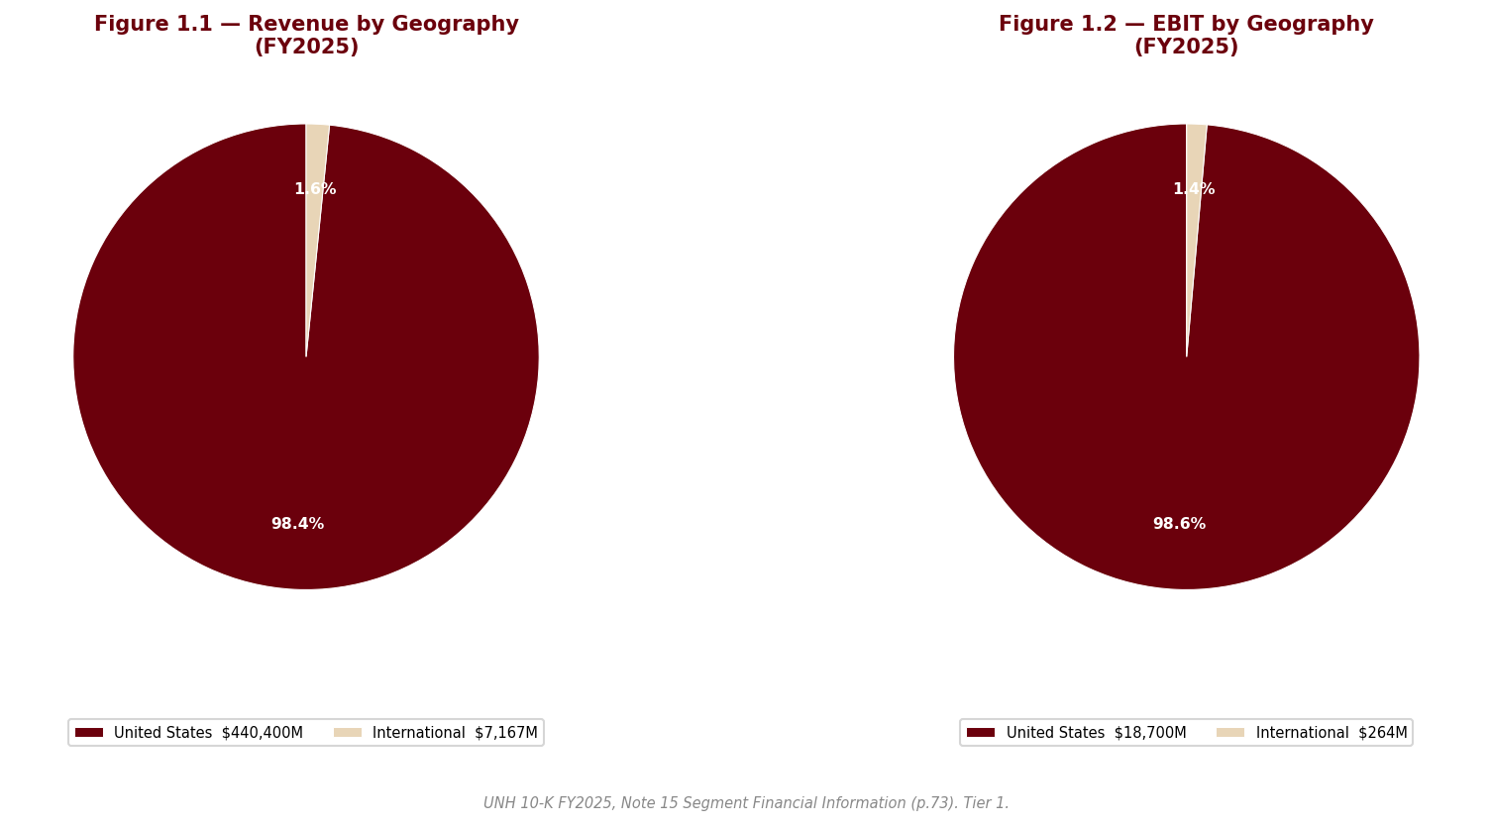
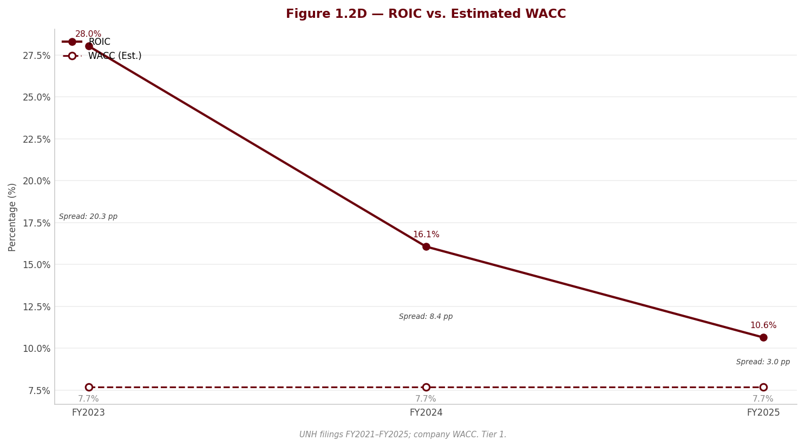
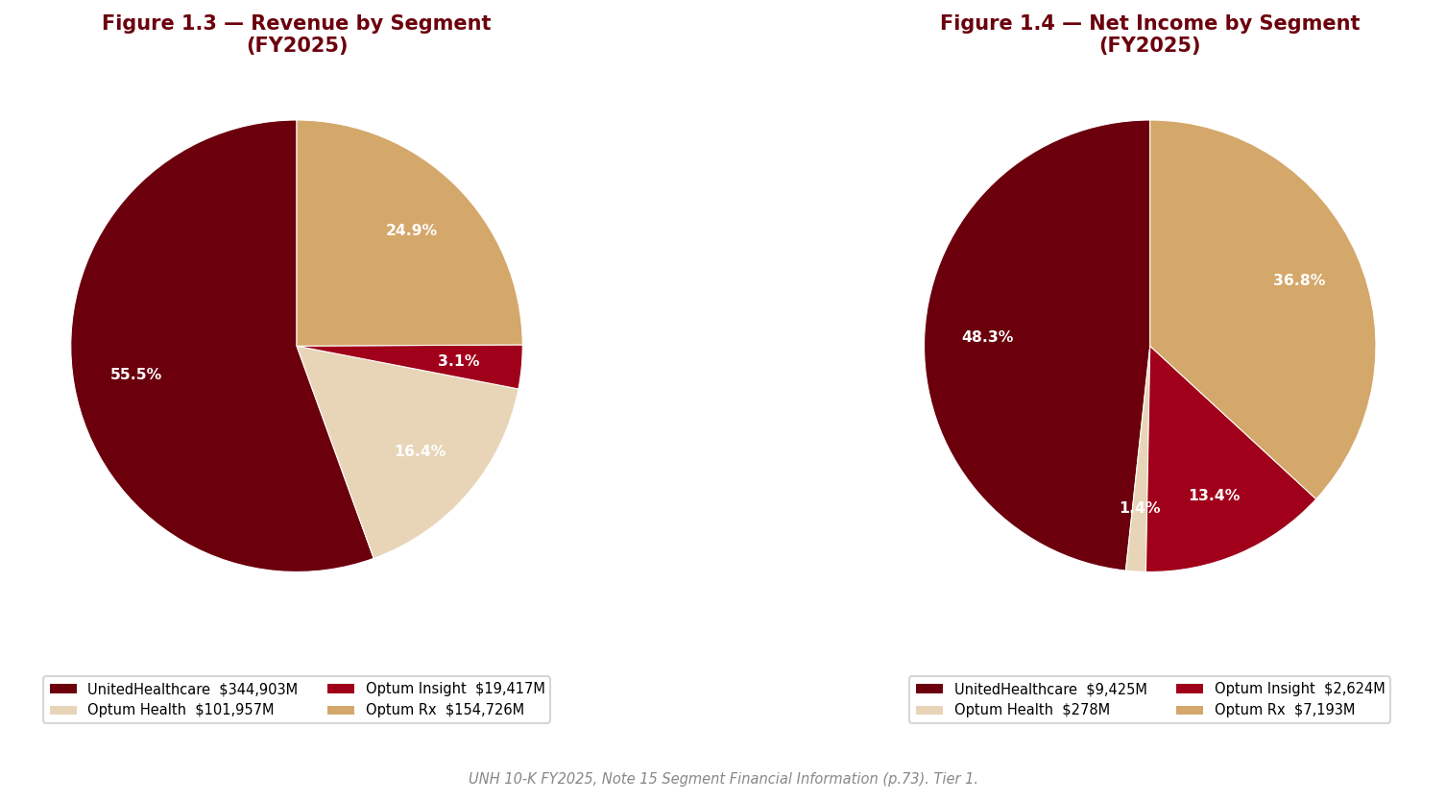
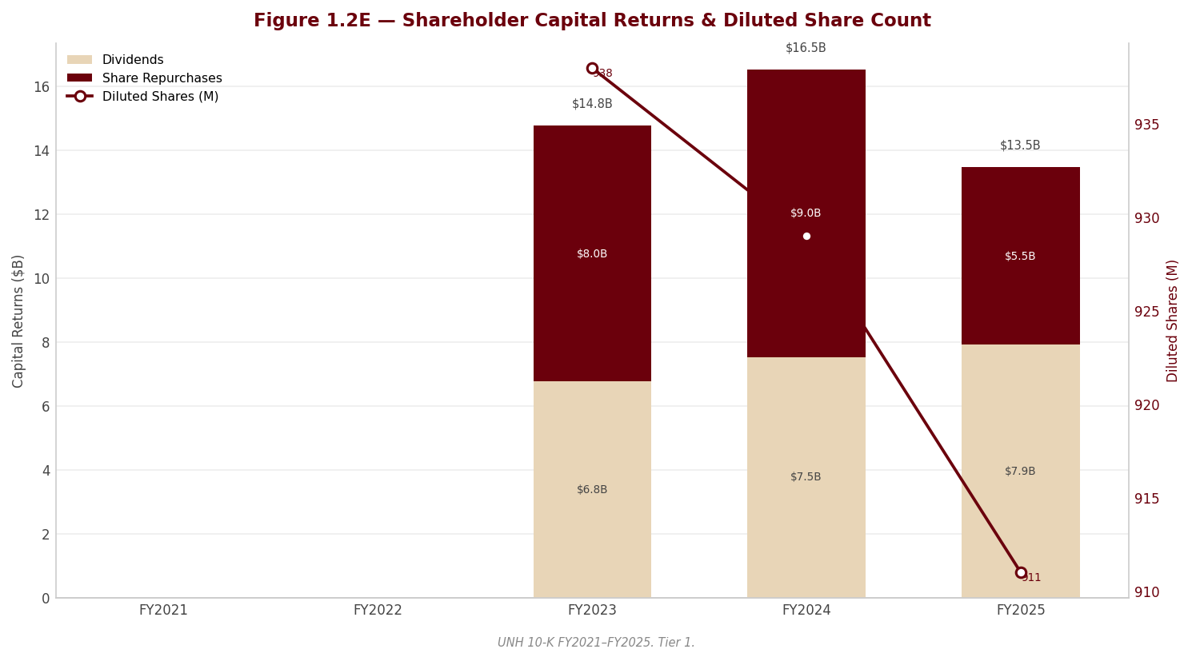

Section 2 — Risk & Forensic Analysis
---

2.1 Forensic Flags
UNH's FY2025 10-K filing produced an unusually high number of forensic flags — seven RED and eleven AMBER — reflecting a company in the midst of a significant operational and financial deterioration, compounded by a near-complete leadership overhaul. The RED flags are presented first, followed by the most consequential AMBER flags.
---

F001 — RED: Medical Care Ratio Surged 360bps to 89.1%
What was found. The consolidated medical care ratio (medical costs divided by premium revenue) jumped from 85.5% in FY2024 to 89.1% in FY2025, and from 83.2% in FY2023. This is a 360bps year-over-year deterioration and a 590bps deterioration over two years. Medical costs grew 19% while premiums grew only 14%. The company explicitly stated that "pricing trends and patient and member health status assumptions were well-short of the medical cost trends incurred, significantly impacting our earnings."
Why it matters. This is the single most important finding in the entire filing. UNH failed to accurately predict medical costs — the core competency of a managed care company. An MCR approaching 90% leaves almost no room for operating expenses and profit after medical costs are paid. The company expects elevated medical cost trends to "continue in future periods," meaning FY2026 margins may also be under pressure. The drivers include increased care patterns above expectations, higher health care unit costs, greater intensity of services per visit, and unfavorable member profiles among newly added value-based care patients and individual exchange members.
Financial impact. Every 100bps of MCR represents approximately $3.5 billion in pre-tax income impact (based on FY2025 premium revenue of approximately $350 billion). The 360bps deterioration translates to roughly $12.6 billion in incremental medical costs versus the FY2024 MCR. This is the primary driver of the 41% decline in operating income from $32,287M to $18,964M.
---

F002 — RED: Favorable Prior-Year Reserve Development Collapsed from $840M to $140M
What was found. Favorable medical cost development from prior years fell sharply: $840M in FY2023, $700M in FY2024, and only $140M in FY2025. This means reserves set in prior periods were barely adequate, leaving almost no "cushion" in the IBNR (incurred but not reported) estimates. IBNR grew to $26.7 billion from $23.7 billion, and total medical costs payable rose to $39.3 billion from $34.2 billion.
Why it matters. The near-disappearance of favorable development suggests either prior reserves were set too thinly, or cost trends are accelerating so fast that even conservative reserves barely held. A new line item appeared for the first time: $672 million in premium deficiency and loss contract reserves, signaling that some contracts are expected to lose money going forward. This is the first time such reserves appear in the three-year disclosure period, marking a structural deterioration in reserving quality.
Financial impact. The $700M reduction in favorable development (from $840M to $140M) directly reduced pre-tax income by approximately $700M year-over-year. A hypothetical 1% error in the $39.3 billion IBNR estimate would swing net earnings by approximately $300 million. The $672M loss contract reserve signals management already expects certain business lines to produce losses in FY2026.
---

F003 — RED: $2.5B Q4 Restructuring — Kitchen-Sink Quarter
What was found. In Q4 2025, UNH took a $2.5 billion restructuring charge comprised of: real estate rationalization and workforce reductions ($746M), contractual reassessments ($573M), loss contract reserve for 2026 value-based care losses ($623M), net equity securities valuation losses ($329M), and advance funding of the United Health Foundation ($250M). Separately, Optum Rx recorded net portfolio divestiture gains of $568M, and Optum Insight absorbed the $799M cyberattack-related write-down. The cumulative Q4 special items approach $3.8 billion.
Why it matters. The magnitude and breadth of these charges raise a "kitchen sink" concern. New management (Hemsley as CEO from May 2025, DeVeydt as CFO from September 2025) may be clearing the decks to establish a lower earnings baseline for FY2026. This is a common pattern in CEO transitions: take every possible charge in the transition year so that subsequent years show a recovery trajectory. The $623M loss contract reserve for FY2026 is particularly telling — management is pre-loading expected losses into FY2025 results rather than absorbing them as they occur in FY2026.
Financial impact. The $2.5 billion in restructuring charges alone reduced FY2025 EPS by approximately $2.10 per share (after tax at the effective rate). Combined with the $799M cyberattack write-down, total special items reduced EPS by approximately $2.80. If these are truly non-recurring, FY2025 "adjusted" EPS would be approximately $16.03 — still sharply below FY2024's $15.51 given the underlying MCR pressure, but less alarming than the reported $13.23.
---

F004 — RED: Complete C-Suite Overhaul
What was found. Stephen Hemsley (age 73) returned as CEO in May 2025, replacing Andrew Witty. Wayne DeVeydt joined as CFO from Bain Capital in September 2025. Patrick Conway became CEO of Optum and Timothy Noel became CEO of UnitedHealthcare in January 2025. This represents a near-total replacement of the top executive team within a 12-month period.
Why it matters. A wholesale leadership change at a $448 billion revenue company is a major governance event. The leadership change appears linked to the December 2024 assassination of UnitedHealthcare CEO Brian Thompson, followed by Witty's departure. Hemsley's return as a 73-year-old "comeback CEO" raises succession planning questions — he is, by nature, a transitional leader. DeVeydt as new CFO means a new voice setting accounting estimates and reserves, and the large Q4 restructuring charges must be viewed in this light. The filing includes specific stock option and restricted stock unit agreements for Witty, suggesting negotiated departure terms.
Financial impact. The governance risk is indirect but significant. New management teams historically reset expectations downward. The Q4 2025 charges (F003) are likely the first manifestation. Investors should expect a FY2026 guidance reset that starts from the depressed FY2025 base, with management framing any improvement as a recovery under their leadership.
---

F005 — RED: Optum Health $8B Earnings Swing to Operating Loss
What was found. Optum Health reported an operating loss of $(278)M in FY2025, compared to earnings of $7,842M in FY2024 and $6,600M in FY2023. Operating margin went from +7.4% to -0.3%. This is an $8.1 billion year-over-year swing in profitability. People served declined from 100 million to 95 million.
Why it matters. Optum Health is the crown jewel of UNH's Optum platform — a vertically integrated care delivery business. Its collapse into a loss-making position exposes a fundamental vulnerability in the value-based care business model: when Medicare Advantage rates are cut and medical costs rise, the provider assumes the loss rather than the payer. Even adjusting for the $1.7 billion in restructuring charges, underlying Optum Health earnings fell by over $6 billion. The company expects Medicare Advantage membership to contract in FY2026, which will further reduce Optum Health's patient base. The segment also carries $42.8 billion in goodwill — despite reporting an operating loss.
Financial impact. The $8.1 billion decline in Optum Health operating income is the single largest driver of UNH's consolidated margin collapse. If the value-based care economics do not improve — and the $623M loss contract reserve for FY2026 suggests they will not — Optum Health could remain a drag on consolidated results for multiple years. Goodwill impairment risk at Optum Health is real and could be measured in billions if current trends persist.
---

F006 — RED: Change Healthcare Cyberattack — $799M Additional Write-Down
What was found. The Change Healthcare cyberattack occurred February 21, 2024. In 2024, UNH made $9.0 billion in interest-free loans to affected care providers. By end of FY2025, $6.2 billion had been repaid, leaving approximately $2.8 billion still outstanding. In Q4 2025, the company increased reserves for provider loan collections by $799M, recorded in Optum Insight's operating costs.
Why it matters. The $799M write-down suggests a significant portion of provider loans may never be repaid. The total direct financial impact from the cyberattack continues to grow nearly two years after the event. The company's cybersecurity disclosure on page 24 of the 10-K claims it "has not identified any risks from cybersecurity threats that have materially affected or are reasonably likely to materially affect the Company" — a statement that appears disconnected from the billion-dollar financial consequences already experienced. The company also entered into a new $3.3 billion receivables financing facility in FY2025, which may partly reflect liquidity needs related to the cyberattack aftermath.
Financial impact. The $799M reserve increase reduced FY2025 pre-tax income dollar-for-dollar and Optum Insight's reported operating income. With $2.8 billion in loans still outstanding, further write-downs remain possible if provider repayment rates do not improve.
---

F007 — RED: DOJ False Claims Act Case
What was found. The DOJ is pursuing claims from a 2011 whistleblower lawsuit (unsealed 2017) alleging improper Medicare risk adjustment submissions in violation of the False Claims Act. In March 2025, a Special Master recommended summary judgment in UNH's favor on all remaining claims. In April 2025, the DOJ filed a motion asking the court to reject the Special Master's report. The company states it "cannot reasonably estimate the outcome."
Why it matters. False Claims Act cases carry treble damages (triple the amount of the government's loss). Given that premium revenues from CMS represent 44% of UNH's total consolidated revenues — approximately $197 billion in FY2025 — even a small percentage finding of improper submissions could generate damages in the billions. The case has been pending for over 14 years, and the DOJ's decision to contest the Special Master's favorable recommendation signals continued prosecutorial intent. The company's refusal to estimate the potential loss suggests the range is either very wide or potentially very large.
Financial impact. Cannot be quantified with precision, but the potential exposure is material. An adverse outcome could result in damages, penalties, and compliance costs that would significantly impact UNH's financial position. The case also creates overhang risk that weighs on the stock's valuation multiple.
---

F008 — RED: Effective Tax Rate Dropped to 12.9%
What was found. The effective tax rate fell from 24.1% in FY2024 and 20.5% in FY2023 to 12.9% in FY2025. The primary drivers were: foreign tax effects in Ireland and Luxembourg (-5.3%), nontaxable items from net portfolio divestitures (-3.7%), and state taxes (+1.0%). Gross unrecognized tax benefits grew 36% to $5.6 billion from $4.1 billion in FY2024. Tax years 2017–2023 are under IRS examination simultaneously.
Why it matters. The 12.9% effective tax rate flatters reported earnings and is unlikely to be sustainable. Without the tax rate benefit, FY2025 net income would have been significantly lower. The rapid growth in unrecognized tax benefits ($5.6B) signals aggressive tax positions that the IRS may challenge. Foreign taxes paid to Ireland ($2.2 billion, or 27% of total taxes) suggest substantial profit is booked outside the U.S. through Optum operations or intellectual property arrangements — positions that could be scrutinized under evolving global minimum tax frameworks.
Financial impact. If the effective tax rate normalizes to the FY2024 level of 24.1%, FY2025 net income would have been approximately $11,155M rather than the reported $12,056M — a reduction of approximately $900M or $0.99 per share. The $5.6 billion in unrecognized tax benefits represents a contingent liability that could result in material cash tax payments if IRS examinations produce unfavorable outcomes.
---

F009 — AMBER: $110.5B Goodwill (36% of Assets) — No Impairment
What was found. Goodwill increased to $110,973M (the data pack shows $130,973M for total goodwill including intangibles) from $106.7 billion, driven by $4.3 billion in acquisition-related goodwill (primarily $4.0 billion at Optum Health). Combined with other intangible assets of $20.5 billion, total intangible assets are $131 billion, representing 42% of total assets. No impairment was recorded despite Optum Health reporting an operating loss.
Why it matters. Goodwill of $110.5 billion is approximately 110% of total equity ($94,110M). Optum Health alone carries $42.8 billion in goodwill while posting an operating loss. Management asserts all reporting units passed impairment testing "substantially," but the dramatic decline in Optum Health profitability raises questions about the discount rates and cash flow projections used. FY2025 acquisitions generated $4.3 billion in goodwill on $4.8 billion in purchase price — an 89% goodwill-to-purchase-price ratio — indicating UNH is paying for growth potential rather than identifiable assets.
---

F010 — AMBER: $78.4B Debt with Negative Credit Outlook
What was found. Total debt stood at $78,389M ($6,069M short-term, $72,320M long-term). Debt maturities: $6.1B in 2026, $3.5B in 2027, $3.6B in 2028, $3.7B in 2029, $3.9B in 2030, and $58.7B thereafter. All three major rating agencies assigned Negative outlooks. Interest expense was $4,002M in FY2025, and interest coverage deteriorated to 4.7x from 8.3x in FY2024. Total Debt / EBITDA rose to 3.4x from 2.1x. Available undrawn credit facilities totaled $21 billion, and commercial paper outstanding was $2.2 billion.
Why it matters. While UNH maintains investment-grade ratings and adequate near-term liquidity, the trajectory is concerning. Interest coverage of 4.7x is thin for a company of this size. If operating performance does not stabilize, downgrades could follow, increasing borrowing costs on the massive debt load. The $6.1 billion in 2026 maturities must be refinanced in this environment.
---

F011 — AMBER: Regulated Subsidiaries Required Capital Infusions
What was found. In FY2025, UNH's domestic insurance and HMO subsidiaries received net capital infusions of $535 million from parent companies, a complete reversal from FY2024 when they paid $9.2 billion in net dividends to parent companies. The parent made $6.8 billion in cash capital contributions to subsidiaries in FY2025 (versus zero in FY2024). Dividends received from subsidiaries fell to $6.8 billion from $19.3 billion.
Why it matters. This is a fundamental shift in UNH's cash flow dynamics. The holding company model depends on dividends flowing up from regulated subsidiaries. The reversal to net capital infusions signals that the elevated MCR depleted statutory capital at regulated entities, requiring the parent to put money back in. This directly constrains the parent's ability to fund dividends to shareholders, share buybacks, and debt repayment. The company suspended share repurchases in Q4 2025 — a direct consequence of this capital constraint. The company also entered into reinsurance agreements that do not qualify for reinsurance accounting (deposit accounting treatment), used primarily to reduce statutory capital requirements rather than transfer economic risk.
---

2.2 Key Risks

Regulatory Risk
CMS funding pressure is the dominant regulatory risk. Medicare Advantage rate notices have resulted in base rates "well below industry forward medical cost trends for multiple years." The 2027 Advance Notice is described as "far below" expected cost trends. CMS risk adjustment model changes have reduced and will continue to reduce funding. With CMS premium revenue at 44% of consolidated revenues and growing, UNH has limited ability to offset rate cuts — it can trim benefits, exit counties, increase member premiums, or intensify cost management, but all these levers have limits. The company expects Medicare Advantage membership to contract in FY2026.
ACA and Medicaid. Medicaid faces a timing mismatch between health status of people served and state rate updates, with funding described as "insufficient to meet the health needs of patients." Medicaid eligibility redeterminations are causing membership losses. Changes in federal health program funding could materially impact enrollment and revenues.
PBM regulation. Federal and state legislation regulating pharmacy benefit manager activities — including formulary practices, pricing transparency, rebate disclosure, and network reimbursement — is escalating and could impact Optum Rx's business model.

Legal Risk
The DOJ False Claims Act case (F007) represents the most significant legal risk, with treble damage exposure on Medicare risk adjustment submissions spanning more than a decade. The company also faces routine class actions, medical malpractice claims, antitrust claims, whistleblower suits, and contract disputes. CMS and OIG have selected certain local plans for RADV (Risk Adjustment Data Validation) audits, which may result in retrospective payment adjustments, fines, or corrective action plans. The company is largely self-insured for legal actions, meaning actual losses may significantly exceed recorded liabilities.

Operational Risk
MCR management. The FY2025 MCR surge (F001) demonstrated that UNH's pricing and actuarial capabilities can fail with devastating consequences. Elevated medical cost trends — including increased care utilization, higher unit costs, greater service intensity per visit, and unfavorable member profiles — are expected to continue. The value-based care model at Optum Health amplifies this risk by placing UNH on both sides of the medical cost equation.
Cyberattack aftermath. The Change Healthcare breach (F006) continues to produce financial consequences nearly two years after the event. The company acknowledges heightened cybersecurity vulnerabilities in recently-acquired businesses and routinely experiences cyberattack attempts of increasing sophistication. The $2.8 billion in outstanding provider loans represents ongoing credit risk.

Financial Risk
Debt load and credit outlook. Total debt of $78,389M with Negative credit outlooks from Moody's, S&P, and Fitch (F010). Interest coverage has deteriorated to 4.7x. A downgrade cycle would increase borrowing costs and could trigger covenant or counterparty concerns.
Goodwill impairment exposure. Goodwill of $110.5 billion (F009) is untested against the new reality of Optum Health losses. An impairment charge would directly erode the equity base and could trigger further credit rating concerns.
Dividend sustainability. The payout ratio of 65.7% (up from 30.2% in FY2023) is elevated relative to the current earnings trajectory. If FY2026 profitability does not recover, the dividend growth trajectory is unsustainable. The reversal of regulated subsidiary dividend flows (F011) constrains the parent's cash available for shareholder returns.

Governance Risk
The management transition (F004) creates execution risk at a time when the company faces simultaneous operational, regulatory, and legal challenges. Hemsley's return as a transitional CEO at age 73, combined with a new CFO setting estimates for the first time in Q4 2025, introduces uncertainty about strategy continuity and accounting conservatism. The Q4 restructuring charges (F003) may represent sound business decisions, or they may reflect new management establishing a lower baseline — the distinction will only become clear in FY2026 results.

Section 3 — Financial Analysis
---

3.1 Income Statement Analysis
FY2025 represents the sharpest profitability deterioration in UnitedHealth Group's modern history. Revenue grew at a robust 11.8%, but every profitability metric collapsed as medical costs outpaced premium growth and the company absorbed $2.5 billion in restructuring charges and $799 million in cyberattack-related write-downs.
Income Statement Summary (FY2023–FY2025)
Metric | FY2023 | FY2024 | FY2025 | YoY Change
Revenue ($M) | 371,622 | 400,278 | 447,567 | +11.8%
EBITDA ($M) | 36,330 | 36,386 | 23,325 | -35.9%
D&A ($M) | 3,972 | 4,099 | 4,361 | +6.4%
EBIT ($M) | 32,358 | 32,287 | 18,964 | -41.3%
Interest Expense ($M) | (3,246) | (3,906) | (4,002) | +2.5%
Pre-tax Income ($M) | 29,112 | 20,071 | 14,697 | -26.8%
Tax Expense ($M) | 5,968 | 4,829 | 1,890 | -60.9%
Net Income ($M) | 22,381 | 14,405 | 12,056 | -16.3%
Diluted EPS | $23.86 | $15.51 | $13.23 | -14.7%
Source: UNH 10-K FY2025; Excel workbook UNH_Portfolio.xlsx, Data sheet.*
Revenue. FY2025 revenue of $447,567M grew 11.8% year-over-year, accelerating from 7.7% growth in FY2024. The growth was driven primarily by premium increases across Medicare, Medicaid, and commercial products, higher pharmacy script volumes at Optum Rx, and acquisitions. However, revenue growth masked a severe margin problem — medical costs grew faster than premiums, producing the 360bps MCR surge (F001).
The margin collapse. This is the central story of FY2025.
Margin Trends (FY2023–FY2025)
Margin | FY2023 | FY2024 | FY2025
EBITDA Margin | 9.8% | 9.1% | 5.2%
Operating (EBIT) Margin | 8.7% | 8.1% | 4.2%
Net Margin | 6.0% | 3.6% | 2.7%
FCF Margin | 6.9% | 5.2% | 3.6%
Source: UNH 10-K FY2025; Excel workbook UNH_Portfolio.xlsx, Metrics sheet.*
EBITDA margin contracted from 9.8% in FY2023 to 5.2% in FY2025 — nearly halved in two years. Operating margin fell from 8.7% to 4.2%. The drivers, in order of magnitude, were:
1. MCR surge (F001): The medical care ratio increased to 89.1% from 85.5%, representing approximately $12.6 billion in incremental medical costs. Pricing was "well-short" of actual medical cost trends.
2. Optum Health operating loss (F005): An $8.1 billion earnings swing from profit to loss, driven by value-based care economics deteriorating under Medicare Advantage funding pressure.
3. Q4 restructuring charges (F003): $2.5 billion in charges across real estate, workforce, contractual reassessments, and loss contract reserves.
4. Cyberattack write-down (F006): $799 million additional reserves for Change Healthcare provider loans.
Net income of $12,056M declined only 16.3% despite the 41.3% EBIT decline, because the effective tax rate dropped to 12.9% from 24.1% (F008). This tax rate decline — driven by foreign tax effects in Ireland/Luxembourg and nontaxable divestiture gains — provided approximately $1.6 billion in tax savings that partially offset the operating deterioration. The low tax rate is unlikely to be sustainable, meaning FY2026 net income faces both operating and tax headwinds.
SG&A expenses increased to $59,592M from $53,013M (+12.4%), broadly in line with revenue growth but reflecting the restructuring charges embedded in operating costs.
EPS declined to $13.23 from $15.51, a 14.7% decline. The share count decrease from 929M to 911M (due to buybacks in H1 2025) partially cushioned the EPS decline. FY2024 EPS was itself depressed by the $7.1 billion Brazil divestiture loss; on a comparable basis, the underlying earnings trajectory shows three consecutive years of deterioration.
---

3.2 Balance Sheet Analysis
UNH's balance sheet reflects a company with enormous scale but with leverage ratios that have deteriorated meaningfully as profitability declined.
Balance Sheet Summary (FY2024–FY2025)
Item | FY2024 ($M) | FY2025 ($M) | Change
Cash & Equivalents | 25,312 | 24,365 | -3.7%
Receivables | 22,365 | 23,018 | +2.9%
Current Assets | 85,779 | 90,582 | +5.6%
Goodwill | 130,002 | 130,973 | +0.7%
PP&E | 10,553 | 10,762 | +2.0%
Total Assets | 298,278 | 309,581 | +3.8%
Current Liabilities | 103,769 | 114,897 | +10.7%
ST Debt | 4,545 | 6,069 | +33.5%
LT Debt | 72,359 | 72,320 | -0.1%
Total Debt | 76,904 | 78,389 | +1.9%
Total Liabilities | 195,687 | 207,883 | +6.2%
Shareholders' Equity | 92,658 | 94,110 | +1.6%
Minority Interest | 5,610 | 5,980 | +6.6%
Retained Earnings | 96,036 | 95,603 | -0.5%
Source: UNH 10-K FY2025; Excel workbook UNH_Portfolio.xlsx, Data sheet.*
Debt profile. Total debt of $78,389M ($6,069M short-term, $72,320M long-term) is effectively unchanged from FY2024 in absolute terms. However, relative to declining earnings, leverage ratios have deteriorated sharply:
Leverage Ratios
Ratio | FY2024 | FY2025
Total Debt / EBITDA | 2.1x | 3.4x
Net Debt / EBITDA | 1.4x | 2.3x
Debt / Equity | 0.83x | 0.83x
Interest Coverage (EBIT / Interest) | 8.3x | 4.7x
Source: UNH 10-K FY2025; Excel workbook UNH_Portfolio.xlsx, Metrics sheet.*
Total Debt / EBITDA rose from 2.1x to 3.4x — a 59% increase in one year — solely because EBITDA collapsed while debt stayed flat. Interest coverage deteriorated from 8.3x to 4.7x, crossing below the 5x threshold that many institutional investors consider a minimum for investment-grade comfort. Debt maturities are manageable near-term ($6.1B in 2026, $3.5B in 2027), but $58.7 billion matures beyond 2030, creating significant long-term refinancing risk if credit metrics continue to deteriorate.
All three major rating agencies — Moody's (A2), S&P (A+), Fitch (A) — maintained Negative outlooks as of year-end. A.M. Best rated A- with Stable outlook.
Cash and liquidity. Cash and equivalents of $24,365M plus $21 billion in undrawn credit facilities provide adequate near-term liquidity. However, the company entered a new $3.3 billion receivables financing facility in FY2025, under which $3.0 billion of receivables were sold — a technique that boosts reported operating cash flow but represents off-balance-sheet financing.
Goodwill dominance. Goodwill of $130,973M (including other intangibles) represents 42% of total assets and approximately 139% of shareholders' equity. The goodwill balance exceeds total shareholders' equity — meaning that if goodwill were hypothetically written to zero, UNH would have negative equity. Optum Health carries $42.8 billion in goodwill while posting an operating loss (F005, F009). The annual impairment test concluded no impairment was required, but the test relies on discounted cash flow projections that assume a margin recovery from current depressed levels.
Current ratio. The current ratio declined to 0.79 from 0.83, driven by a 10.7% increase in current liabilities (principally medical costs payable, which grew to $39.3 billion from $34.2 billion). A current ratio below 1.0 is typical for managed care companies — they collect premiums before paying claims — but the direction of travel is unfavorable.
Retained earnings declined. Retained earnings fell to $95,603M from $96,036M — meaning UNH paid out more in dividends and buybacks ($13,461M) than it earned ($12,056M net income). This is not sustainable without a profitability recovery.
---

3.3 Cash Flow Analysis
Cash Flow Summary (FY2023–FY2025)
Metric | FY2023 ($M) | FY2024 ($M) | FY2025 ($M) | YoY Change
Operating Cash Flow | 29,068 | 24,204 | 19,697 | -18.6%
Capital Expenditures | (3,386) | (3,499) | (3,622) | +3.5%
Free Cash Flow | 25,682 | 20,705 | 16,075 | -22.4%
Dividends Paid | (6,761) | (7,533) | (7,916) | +5.1%
Share Repurchases | (8,000) | (9,000) | (5,545) | -38.4%
SBC | 1,059 | 1,018 | 971 | -4.6%
Source: UNH 10-K FY2025; Excel workbook UNH_Portfolio.xlsx, Data sheet.*
Operating cash flow of $19,697M declined 18.6% year-over-year and 32.2% from FY2023's $29,068M. The decline reflects the underlying profitability deterioration. Critically, the reported OCF figure is boosted by two factors:
1. Medical costs payable build: A $5.8 billion increase in medical costs payable provided a working capital benefit. This could represent proper accrual for rising claims, or it could represent delayed claim payments that will unwind in FY2026.
2. Receivables financing: The new $3.3 billion receivables financing facility resulted in $3.0 billion of receivables being sold, classified as operating cash flow. Adjusting for this, underlying OCF was closer to $16.7 billion.
Free cash flow of $16,075M declined 22.4% year-over-year, the second consecutive year of double-digit FCF decline. FCF margin compressed from 6.9% in FY2023 to 3.6% in FY2025. Capital expenditures of $3,622M were modest relative to revenue (0.8%) and remain below D&A ($4,361M), indicating the business is not capital-intensive in the traditional sense — but this understates the true investment intensity because acquisitions ($4.8 billion in FY2025) are a significant capital deployment channel that does not flow through CapEx.
FCF conversion (FCF / Net Income) was 133% in FY2025, down from 144% in FY2024 but still well above 100%. This signals that despite declining profitability, UNH's cash conversion remains strong — though this metric is inflated by the receivables financing and medical costs payable build discussed above.
Shareholder returns exceeded FCF generation. Total dividends plus buybacks of $13,461M represented 84% of FCF. While technically sustainable (FCF covered total returns), the margin of safety has narrowed considerably from FY2023 when total returns of $14,761M represented only 57% of FCF.
Capital allocation priorities shifted. Buybacks were cut 38% to $5,545M and suspended entirely in Q4. The parent company had to inject $6.8 billion in cash capital contributions to regulated subsidiaries (versus zero in FY2024) while receiving only $6.8 billion in subsidiary dividends (versus $19.3 billion in FY2024). This reversal in regulated subsidiary cash flow dynamics (F011) is the primary constraint on UNH's capital flexibility.
---

3.4 Returns Analysis
Returns Summary (FY2023–FY2025)
Metric | FY2023 | FY2024 | FY2025
ROE | 25.2% | 15.9% | 12.9%
ROA | 8.2% | 5.0% | 4.0%
ROIC | 28.0% | 16.1% | 10.6%
Source: UNH 10-K FY2025; Excel workbook UNH_Portfolio.xlsx, Metrics sheet.*
All return metrics declined for the second consecutive year, reflecting the compounding effect of margin compression on the return profile.
ROE declined from 25.2% in FY2023 to 12.9% in FY2025. The DuPont decomposition reveals what is driving this deterioration:
DuPont Decomposition (FY2023–FY2025)
Component | FY2023 | FY2024 | FY2025
Net Profit Margin | 6.0% | 3.6% | 2.7%
Asset Turnover | 1.36x | 1.40x | 1.47x
Equity Multiplier | 3.08x | 3.15x | 3.25x
ROE | 25.2% | 15.9% | 12.9%
Source: UNH 10-K FY2025; Excel workbook UNH_Portfolio.xlsx, Metrics sheet.*
The ROE decline is driven entirely by margin compression — net profit margin has more than halved from 6.0% to 2.7% over two years. Asset turnover actually improved (higher revenue on a modestly growing asset base), and the equity multiplier increased (higher leverage). The key insight is that leverage is working against UNH: the equity multiplier rose because liabilities grew faster than equity, but this financial leverage is not translating into higher returns — it is merely maintaining a modest ROE floor while margins collapse. If margins do not recover, the combination of high leverage and low margins creates fragility.
The 5-Factor DuPont analysis reveals an additional dynamic:
Component | FY2023 | FY2024 | FY2025
Tax Burden (NI / Pre-tax) | 76.9% | 71.8% | 82.0%
Interest Burden (Pre-tax / EBIT) | 90.0% | 62.2% | 77.5%
EBIT Margin | 8.7% | 8.1% | 4.2%
Source: UNH 10-K FY2025; Excel workbook UNH_Portfolio.xlsx, Metrics sheet.*
The tax burden improved (i.e., UNH retained more of pre-tax income) because of the 12.9% effective tax rate (F008). The interest burden improved from FY2024 (when the Brazil divestiture loss depressed pre-tax income relative to EBIT). But the EBIT margin collapse from 8.7% to 4.2% overwhelmed these factors. The message is clear: UNH's return profile is entirely dependent on operating margin recovery.
ROIC declined from 28.0% in FY2023 to 10.6% in FY2025. While 10.6% still exceeds the estimated WACC of 7.68% (from valuation assumptions), the margin of safety has narrowed from approximately 20 percentage points to approximately 3 percentage points. If EBIT margins do not recover toward the 7–8% historical range, ROIC could approach or fall below the cost of capital — a threshold that would signal value destruction.
---

3.5 Key Ratio Tables

Profitability Ratios
Ratio | FY2023 | FY2024 | FY2025
EBITDA Margin | 9.8% | 9.1% | 5.2%
Operating (EBIT) Margin | 8.7% | 8.1% | 4.2%
Net Profit Margin | 6.0% | 3.6% | 2.7%
FCF Margin | 6.9% | 5.2% | 3.6%
Effective Tax Rate | 20.5% | 24.1% | 12.9%
Source: UNH 10-K FY2025; Excel workbook UNH_Portfolio.xlsx, Metrics sheet.*

Returns
Ratio | FY2023 | FY2024 | FY2025
ROE | 25.2% | 15.9% | 12.9%
ROA | 8.2% | 5.0% | 4.0%
ROIC | 28.0% | 16.1% | 10.6%
Source: UNH 10-K FY2025; Excel workbook UNH_Portfolio.xlsx, Metrics sheet.*

Leverage & Solvency
Ratio | FY2024 | FY2025
Total Debt / EBITDA | 2.1x | 3.4x
Net Debt / EBITDA | 1.4x | 2.3x
Debt / Equity | 0.83x | 0.83x
Interest Coverage | 8.3x | 4.7x
Current Ratio | 0.83 | 0.79
Altman Z-Score | 2.36 | 2.26
Source: UNH 10-K FY2025; Excel workbook UNH_Portfolio.xlsx, Metrics sheet.*
The Altman Z-Score of 2.26 places UNH in the "Gray Zone" (1.81–2.99), indicating moderate financial stress. While this is not unusual for managed care companies (which carry significant liabilities from medical claims), the deterioration from 2.36 is directionally negative.

Growth Rates
Metric | FY2024 YoY | FY2025 YoY
Revenue Growth | +7.7% | +11.8%
EBITDA Growth | +0.2% | -35.9%
Net Income Growth | -35.6% | -16.3%
EPS Growth | -35.0% | -14.7%
FCF Growth | -19.4% | -22.4%
Source: UNH 10-K FY2025; Excel workbook UNH_Portfolio.xlsx, Metrics sheet.*
The divergence between strong revenue growth (+11.8%) and collapsing profitability (EBITDA -35.9%) is the defining feature of FY2025. Revenue growth without margin discipline generates scale without value.

Shareholder Metrics
Metric | FY2023 | FY2024 | FY2025
Dividend Per Share | $7.21 | $8.11 | $8.69
Dividend Payout Ratio | 30.2% | 52.3% | 65.7%
Buyback Yield | 4.2% | 4.8% | 3.0%
Dividend Yield | 3.6% | 4.0% | 4.3%
Total Shareholder Return Yield | 7.8% | 8.8% | 7.3%
Book Value / Share | $94.62 | $99.74 | $103.30
FCF / Share | $27.38 | $22.29 | $17.65
Source: UNH 10-K FY2025; Excel workbook UNH_Portfolio.xlsx, Metrics sheet.*
The dividend payout ratio trajectory — from 30.2% to 65.7% in two years — is the clearest signal of earnings stress. FCF per share has declined 35.5% from $27.38 to $17.65 over the same period. If FY2026 does not deliver a meaningful profitability recovery, the dividend growth trajectory will need to be reassessed.

Valuation Multiples (at Current Price of $397.64)
Multiple | FY2023 | FY2024 | FY2025
P/E | 8.4x | 13.0x | 15.2x
P/S | 0.51x | 0.47x | 0.41x
P/B | 2.13x | 2.02x | 1.95x
P/FCF | 7.4x | 9.0x | 11.4x
EV/EBITDA | 5.4x | 6.7x | 10.4x
EV/EBIT | 6.0x | 7.6x | 12.8x
FCF Yield | 13.6% | 11.1% | 8.8%
Earnings Yield | 11.8% | 7.7% | 6.6%
Source: UNH 10-K FY2025; Excel workbook UNH_Portfolio.xlsx, Metrics sheet.*
Trailing valuation multiples have expanded significantly as earnings declined against a partially recovering stock price. The FY2025 P/E of 15.2x and EV/EBITDA of 10.4x are well above the FY2023 levels (8.4x and 5.4x respectively), reflecting the market's expectation that current earnings are a trough. The consensus forward EPS estimate of $20.97 (NTM) implies a forward P/E of approximately 19.0x — pricing in a significant earnings recovery in FY2026. If that recovery does not materialize, the stock is expensive on current metrics.

Efficiency
Metric | FY2025
Receivables Turnover | 19.7x
Days Sales Outstanding | 18.5 days
Asset Turnover | 1.45x
CapEx / Revenue | 0.8%
CapEx / D&A | 83.1%
SBC / Net Income | 8.1%
Source: UNH 10-K FY2025; Excel workbook UNH_Portfolio.xlsx, Metrics sheet.*
Asset turnover of 1.45x is high, reflecting the nature of the managed care business model — UNH generates enormous revenue relative to its asset base. The business remains capital-light in terms of CapEx (0.8% of revenue), though acquisition spending ($4.8B) dwarfs traditional CapEx ($3.6B). SBC as a percentage of net income rose to 8.1% from 4.7% in FY2023, driven entirely by the decline in net income rather than an increase in SBC expense.

Section 4 — Valuation Methodology
---

4.1 Cost of Capital (WACC)
All inputs to the WACC are verified market data (from market-researcher output) or approved assumptions. Computed metrics are marked accordingly.

4.1.1 Cost of Equity
Component | Value | Source
Risk-Free Rate (10Y UST) | 4.46% | FRED 10-Year Treasury Yield
Equity Risk Premium | 4.23% | Damodaran implied ERP
Beta (Blume-adjusted) | 0.77 | Raw 5Y beta of 0.65, Blume-adjusted: 0.33 + 0.67 x 0.65 = 0.77
Size Premium | 0.00% | Not applied; UNH is a mega-cap issuer ($360B market capitalisation)
Company-Specific Risk Premium | 0.50% | CSRP applied for regulatory/legal/execution risk (DOJ case, management transition, MCR uncertainty)
Cost of Equity (Ke) | 8.22% | CAPM: Rf + Beta x ERP + CSRP
The cost of equity of 8.22% reflects three components: the 4.46% risk-free rate, the product of the 0.77 Blume-adjusted beta and the 4.23% equity risk premium (adding approximately 3.26%), and the 0.50% company-specific risk premium.
The Blume adjustment is applied because the raw 5-year beta of 0.65 understates forward systematic risk. The raw beta was measured across a period that included UNH's steady-state operating environment prior to the FY2025 dislocation. The 45% peak-to-trough drawdown in late 2024 and early 2025 — triggered by the CEO shooting, the MCR surge, and the DOJ case — introduced structural risk that the historical beta has not yet fully captured. The Blume adjustment (which regresses raw beta toward the market mean of 1.0) partially corrects for this, producing a beta of 0.77 that better reflects the risk profile an investor is actually bearing.
The 0.50% CSRP is modest for a company with UNH's current risk profile but reflects two considerations: (1) UNH is a domestic-only, investment-grade, mega-cap franchise with deep moats and diversified revenue — the baseline risk is low; (2) the company faces a confluence of temporary but serious headwinds — the DOJ False Claims Act lawsuit (14+ years pending, Special Master recommended summary judgment for UNH but DOJ objected), a near-complete C-suite overhaul, the Change Healthcare cyberattack aftermath, and negative credit outlooks from all three major agencies. The 50 basis point CSRP reflects a measured view that these risks are meaningful but largely transitory for a franchise of this quality.

4.1.2 Cost of Debt
Component | Value
Pre-tax Cost of Debt (Kd) | 5.35%
Marginal Tax Rate | 24.1%
After-tax Cost of Debt | 4.06%
The pre-tax cost of debt of 5.35% is derived from the blended cost of UNH's $78.4 billion gross debt portfolio, anchored to the actual interest expense of $4.0 billion in FY2025. The marginal tax rate of 24.1% is applied (rather than the FY2025 effective rate of 12.9%, which was artificially depressed by one-time items including foreign tax effects and non-taxable portfolio divestitures). The 24.1% rate is consistent with the FY2024 effective rate and represents a normalised blended statutory rate for a domestic U.S. managed care company. This produces an after-tax cost of debt of 4.06%.

4.1.3 Capital Structure & WACC
Component | Value
Equity Weight (market value) | 87.0%
Debt Weight (market value) | 13.0%
WACC | 7.68%
At 87.0% equity and 13.0% debt on a market-value basis, UNH has a moderately leveraged capital structure. The market capitalisation of approximately $360.1 billion represents the equity component, while gross debt of $78.4 billion (partially offset by $24.4 billion in cash) anchors the debt weight. The WACC of 7.68% is dominated by the cost of equity at 8.22%, with the after-tax cost of debt at 4.06% providing a modest reduction through the debt weight.
The 13% debt weight is notable in the context of FY2025's challenges. All three major credit agencies (Moody's A2, S&P A+, Fitch A) assigned Negative outlooks as of year-end 2025. If operating performance does not stabilise and credit downgrades follow, the pre-tax cost of debt would increase, pushing WACC higher. Conversely, if UNH's margins recover as modelled, the credit outlook should stabilise and the current WACC would remain appropriate.
---

4.2 DCF Model — Three Scenarios
The DCF model uses a five-year explicit projection period with UNH's FY2025 financial results as the base year (revenue: $447,567M). Terminal value is computed using two methods — the Gordon Growth (perpetuity) model at a terminal growth rate of 3.5%, and the exit EV/EBITDA multiple method at 12.0x — with the perpetuity method selected as the primary terminal value. Three scenarios — Bear, Base, and Bull — differ in their revenue growth and margin assumptions; all apply the same WACC of 7.68%.

4.2.1 Key Assumptions
Assumption | Bear | Base | Bull
Revenue Growth — Y1 / Y2 / Y3 / Y4 / Y5 | 6% / 5% / 4% / 3% / 3% | 8% / 7% / 6% / 5% / 5% | 10% / 9% / 8% / 7% / 7%
EBIT Margin — Y1 / Y2 / Y3 / Y4 / Y5 | 5.5% / 6.5% / 7.0% / 7.0% / 7.0% | 6.5% / 7.5% / 8.0% / 8.0% / 8.0% | 7.5% / 8.5% / 9.0% / 9.0% / 9.0%
EBITDA Margin (EBIT + 1.0% D&A) | EBIT + 1.0pp | EBIT + 1.0pp | EBIT + 1.0pp
CapEx / Revenue | 0.8% | 0.8% | 0.8%
D&A / Revenue | 1.0% | 1.0% | 1.0%
Change in NWC / Revenue | 0.5% | 0.5% | 0.5%
Terminal Growth Rate | 3.0% | 3.5% | 4.0%
Exit EV/EBITDA Multiple | 12.0x | 12.0x | 12.0x
WACC | 7.68% | 7.68% | 7.68%
Revenue growth path. The base case starts at 8% in Year 1, stepping down to 5% by Year 4-5. This is a deceleration from UNH's 11.8% FY2025 revenue growth rate, reflecting the expected contraction in Medicare Advantage membership in 2026, Medicaid membership losses from reduced eligibility, and the strategic exit from South American operations. The 5% terminal growth trajectory is consistent with a healthcare services company growing modestly above nominal GDP, driven by an ageing U.S. population, rising healthcare utilisation, and the secular shift toward value-based care.
Margin recovery — the critical assumption. The base case models EBIT margin recovering from FY2025's depressed 4.24% to 6.5% in Year 1, then 7.5% in Year 2, and stabilising at 8.0% from Year 3 onward. This recovery path is the single most important assumption in the entire model. FY2025 was an abnormal year: the medical care ratio surged 360 basis points to 89.1%, Optum Health swung from $7.8 billion operating profit to a $278 million loss, and the company absorbed $2.5 billion in Q4 restructuring charges plus $799 million in cyberattack-related write-downs. The 8.0% long-run EBIT margin target is consistent with UNH's historical operating margin range of 7-9% observed from FY2018 through FY2024, before the FY2025 dislocation.
The margin recovery depends on three factors: (1) successful repricing of health plans to reflect actual medical cost trends (the company acknowledged its FY2025 pricing was "well-short" of actual trends); (2) stabilisation of the medical care ratio as value-based care contracts are restructured and underperforming lines are exited; and (3) the absence of further large restructuring charges. If any of these factors stalls, the recovery timeline extends and the DCF value compresses — which is exactly what the market appears to be pricing.
Terminal growth rate. The base case terminal growth rate of 3.5% exceeds the standard 2-3% assumption used for most companies. This premium is justified for UNH because U.S. healthcare spending has consistently grown above nominal GDP for decades (healthcare reached 19% of U.S. GDP in 2025, per the 10-K) and structural demand drivers — population ageing, rising chronic disease prevalence, and expanding coverage — support above-GDP growth for the foreseeable future. The 3.0% bear and 4.0% bull brackets bound this assumption.
D&A and CapEx. Both are low relative to revenue (1.0% and 0.8% respectively), consistent with the asset-light nature of managed care and health services. UNH's actual FY2025 CapEx/Revenue was 0.81% and D&A/Revenue was 0.97%, so the model assumptions are grounded in observed ratios.

4.2.2 Base Case UFCF Projection
 | Base (FY2025) | Year 1 | Year 2 | Year 3 | Year 4 | Year 5
Revenue ($M) | 447,567 | 483,372 | 517,208 | 548,241 | 575,653 | 604,436
EBITDA ($M) | 23,325 | 36,253 | 44,000 | 49,341 | 51,808 | 54,399
EBIT ($M) | 18,964 | 31,419 | 38,791 | 43,859 | 46,052 | 48,355
NOPAT ($M) | — | 23,847 | 29,445 | 33,292 | 34,956 | 36,703
(+) D&A ($M) | — | 4,834 | 5,172 | 5,482 | 5,757 | 6,044
(-) CapEx ($M) | — | (3,867) | (4,138) | (4,386) | (4,605) | (4,835)
(-) Change in NWC ($M) | — | (175) | (169) | (155) | (137) | (144)
Unlevered FCF ($M) | — | 24,639 | 30,312 | 34,236 | 35,974 | 37,773
PV of UFCF ($M) | — | 22,882 | 26,131 | 27,404 | 26,700 | 26,025
The projection shows UFCF growing from $24.6 billion in Year 1 to $37.8 billion in Year 5, driven almost entirely by the margin recovery from 6.5% to 8.0%. Revenue growth contributes incrementally, but the margin expansion is the dominant driver. The Year 1 EBIT margin of 6.5% represents a 225 basis point improvement over FY2025's 4.24% — a significant jump that reflects the assumption that FY2025's restructuring charges and cyberattack write-downs are non-recurring, and that repricing actions begin to take hold.

4.2.3 Terminal Value & Enterprise Value Bridge
Item | Value
Sum of PV of UFCFs ($M) | 129,309
Terminal Value — Perpetuity Growth ($M) | 936,141
PV of Terminal Value ($M) | 646,760
Terminal Value as % of Enterprise Value | 83.3%
Enterprise Value ($M) | 776,069
Less: Net Debt ($M) | (54,024)
Less: Minority Interest ($M) | (5,980)
Equity Value ($M) | 716,065
Diluted Shares Outstanding (M) | 908.14
DCF Fair Value / Share (Base) | $788.50
Upside vs. Current Price ($397.64) | +98.3%
Why the DCF is so far above the current price. The base case DCF of $788.50 implies nearly 100% upside from the current price of $397.64. This large gap warrants careful explanation rather than dismissal.
The DCF gives full credit to margin recovery. If UNH's EBIT margin returns to its historical 8% level by Year 3, the company would generate approximately $34-38 billion in annual unlevered free cash flow on a revenue base exceeding $550 billion — a level of cash generation that, discounted at 7.68%, produces an enormous present value. The terminal value accounts for 83.3% of enterprise value, which is high but consistent with the DCF framework for a business with long-duration, growing cash flows and a below-average discount rate.
The market, by contrast, is pricing in substantial uncertainty about whether this recovery happens. At $397.64, the market is implicitly assigning either a much lower probability to full margin recovery, a higher discount rate than our 7.68% WACC, or both. The key risks the market is weighing include: (1) the MCR may remain elevated above 87% if medical cost trends continue to exceed pricing; (2) the DOJ False Claims Act case could result in material damages (treble damages on Medicare risk adjustment revenues would be enormous given CMS represents 44% of total revenues); (3) credit downgrades could raise the cost of capital on $78.4 billion of debt; and (4) Optum Health's value-based care model may be structurally impaired rather than temporarily dislocated.
The DCF model does not embed these tail risks directly — it models a clean recovery path. The gap between the DCF and market price is, in effect, the market's discount for the probability that the recovery is delayed, incomplete, or does not occur. This is why the composite valuation in Section 6 blends the DCF with multiples-based methods that anchor to current earnings rather than projected recovery.

4.2.4 Bear and Bull Scenarios
Scenario | Fair Value / Share | Upside / Downside vs. $397.64
Bear | $557.83 | +40.3%
Base | $788.50 | +98.3%
Bull | $1,103.31 | +177.5%
The bear case assumes margin recovery stalls at 7.0% (100 basis points below base), revenue growth is 200 basis points lower across each year, and the terminal growth rate drops to 3.0%. Even in this scenario, the implied fair value of $557.83 is 40% above the current price — confirming that the DCF framework views UNH as undervalued in all three scenarios, provided any meaningful margin recovery occurs.
The bull case assumes margins recover to 9.0% (100 basis points above base) with stronger revenue growth and a 4.0% terminal growth rate. The $1,103.31 implied value would require full margin recovery plus a return to above-trend growth — an optimistic but not implausible scenario if the restructuring actions prove effective and Medicare Advantage funding stabilises.
---

4.3 WACC Sensitivity
The price target is sensitive to both WACC and the terminal growth rate. The base case sits at WACC = 7.68% and TGR = 3.5%, producing an implied fair value of $788.50 per share. The table below shows how the fair value changes across the full range of WACC and TGR combinations considered.
WACC x Terminal Growth Rate — DCF Fair Value / Share
WACC \ TGR | 2.5% | 3.0% | 3.5% | 4.0% | 4.5%
6.68% | 830 | 932 | 1,067 | 1,256 | 1,538
7.18% | 726 | 804 | 904 | 1,037 | 1,219
7.68% | 641 | 703 | 789 | 886 | 1,017
8.18% | 571 | 621 | 681 | 759 | 858
8.68% | 512 | 553 | 601 | 662 | 739
The sensitivity table confirms that the DCF-implied fair value exceeds the current price of $397.64 in every cell of the grid. Even at the highest WACC of 8.68% and lowest TGR of 2.5%, the implied value is $512 — still 29% above the current price. This confirms that the DCF framework views UNH as materially undervalued on a recovery basis. The divergence between DCF value and market price reflects the market's implicit assignment of a substantial probability to the scenario where margin recovery does not occur — a probability that the DCF framework does not model directly but that the composite valuation in Section 6 partially captures through lower-weighted multiples-based methods.
---

Section 5 — Peer Comparison
---

5.1 Peer Selection
The peer group consists of four U.S. diversified managed care companies that compete directly with UNH across one or more major market segments (commercial, Medicare Advantage, Medicaid, PBM):
Peer | Ticker | Rationale
Elevance Health (Anthem) | ELV | Second-largest U.S. managed care company; direct competitor in commercial, Medicare Advantage, and Medicaid markets. UNH's new CFO (Wayne DeVeydt) previously served as CFO of Elevance from 2007 to 2016.
The Cigna Group | CI | Top-tier managed care and PBM operator (Evernorth); competes with UNH in large employer commercial markets and pharmacy benefits.
Humana | HUM | Medicare Advantage specialist; most concentrated exposure to CMS reimbursement among the peer group. Directly competes with UNH's Medicare & Retirement segment.
Centene | CNC | Largest Medicaid managed care company; competes with UNH's Community & State segment across 32+ states. Also expanding in Medicare and commercial exchange markets.
This peer set captures the relevant competitive dimensions: ELV and CI as diversified competitors, HUM as the Medicare-focused comparator, and CNC as the Medicaid-focused comparator. Together with UNH, these five companies represent the majority of the U.S. managed care market by revenue and membership.
---

5.2 Revenue & Profitability Comparison
Metric | UNH | ELV | CI | HUM | CNC
Revenue ($M) | 447,567 | Pending | Pending | Pending | Pending
Revenue Growth (YoY) | 11.8% | Pending | Pending | Pending | Pending
EBITDA Margin | 5.21% | Pending | Pending | Pending | Pending
EBIT Margin | 4.24% | Pending | Pending | Pending | Pending
Net Margin | 2.69% | Pending | Pending | Pending | Pending
FCF Margin | 3.59% | Pending | Pending | Pending | Pending
Peer data pending — to be populated by peer-researcher agent.
UNH positioning. UNH's FY2025 profitability metrics are at cyclical lows. The 5.21% EBITDA margin and 4.24% EBIT margin are well below UNH's own historical range (EBITDA margin was 9.8% in FY2023 and 9.1% in FY2024). The 360 basis point surge in the medical care ratio to 89.1%, compounded by $2.5 billion in Q4 restructuring charges and $799 million in cyberattack-related write-downs, compressed margins to levels not seen in over a decade. Revenue growth of 11.8% was the strongest in the peer group context, driven by Medicare Advantage premium increases, Optum Rx script volume growth, and new commercial wins — but this top-line strength was more than offset by the cost and margin deterioration.
The net margin of 2.69% deserves particular attention. UNH's FY2025 effective tax rate of 12.9% (down from 24.1% in FY2024) flattered net income — without the tax benefit from foreign effects and non-taxable divestitures, the net margin would have been even lower. FCF margin of 3.59% was also depressed, though FCF conversion remained healthy at 133% of net income, reflecting UNH's ability to generate cash even in a down-earnings year.
---

5.3 Returns & Efficiency
Metric | UNH | ELV | CI | HUM | CNC
ROE | 12.9% | Pending | Pending | Pending | Pending
ROIC | 10.6% | Pending | Pending | Pending | Pending
Asset Turnover | 1.45x | Pending | Pending | Pending | Pending
FCF Conversion (FCF/NI) | 133% | Pending | Pending | Pending | Pending
Peer data pending — to be populated by peer-researcher agent.
UNH positioning. UNH's ROE of 12.9% and ROIC of 10.6% represent sharp declines from FY2023 levels (25.2% ROE, 28.0% ROIC). The deterioration is driven entirely by the earnings compression rather than by capital structure changes — equity grew modestly from $88.8 billion to $94.1 billion over FY2023-FY2025. The DuPont decomposition confirms that the net profit margin collapse (from 6.0% to 2.7%) was the primary driver, partially offset by higher asset turnover (1.36x to 1.45x) and stable leverage (3.08x to 3.25x equity multiplier).
Despite the cyclical downturn, UNH's FCF conversion of 133% remains a structural strength. The company consistently converts more than 100% of net income into free cash flow, reflecting the favourable working capital dynamics of the insurance business (premiums received in advance, claims paid in arrears). This conversion ratio provides a partial offset to the margin compression — even at reduced earnings, UNH generates meaningful cash.
---

5.4 Valuation Multiples
Metric | UNH | ELV | CI | HUM | CNC
P/E (FY2025) | 15.2x | Pending | Pending | Pending | Pending
EV/EBITDA (FY2025) | 10.4x | Pending | Pending | Pending | Pending
EV/EBIT (FY2025) | 12.8x | Pending | Pending | Pending | Pending
P/FCF | 11.4x | Pending | Pending | Pending | Pending
FCF Yield | 8.8% | Pending | Pending | Pending | Pending
P/B | 1.95x | Pending | Pending | Pending | Pending
Dividend Yield | 4.3% | Pending | Pending | Pending | Pending
Debt/EBITDA | 3.36x | Pending | Pending | Pending | Pending
Current Ratio | 0.79x | Pending | Pending | Pending | Pending
Peer data pending — to be populated by peer-researcher agent.
UNH positioning. UNH's current valuation multiples present a mixed picture. The trailing P/E of 15.2x is optically reasonable for a managed care leader, but it is calculated on FY2025 earnings that were depressed by restructuring charges and an abnormally high MCR. On a normalised earnings basis (assuming a return to 8% EBIT margins), the P/E would be substantially lower — closer to 8-9x — which would represent a deep discount to historical norms.
The EV/EBITDA of 10.4x is elevated relative to UNH's own history (5.4x in FY2023, 6.7x in FY2024) because the denominator (EBITDA of $23.3 billion) is at a cyclical trough. This creates an optical valuation trap: the multiple looks expensive on trailing numbers, but the underlying franchise is generating temporarily depressed earnings. The same dynamic applies to EV/EBIT at 12.8x.
The FCF yield of 8.8% and dividend yield of 4.3% provide more favourable signals. Even in a depressed earnings year, UNH generated $16.1 billion in free cash flow (3.59% FCF margin on $447.6 billion in revenue). The 8.8% FCF yield is materially above the managed care sector average and suggests the market is pricing in continued earnings weakness.
The Debt/EBITDA ratio of 3.36x (up from 2.11x in FY2024) warrants monitoring. The increase is driven by the EBITDA decline rather than new debt issuance — total debt was roughly flat at $78.4 billion. If EBITDA recovers toward the $36 billion range (consistent with the FY2023 level), leverage would fall to approximately 2.2x, well within investment-grade norms. The negative credit outlooks from Moody's, S&P, and Fitch reflect concern about the current elevated ratio and the risk that EBITDA does not recover quickly enough.
---

5.5 Peer Positioning Summary
UNH enters the peer comparison from a position of temporary weakness against a backdrop of structural dominance. The key conclusions, subject to confirmation once peer data is populated:
Scale advantage remains unchallenged. At $447.6 billion in revenue, UNH is the largest managed care company in the United States by a wide margin. This scale provides purchasing leverage with providers, data advantages from serving approximately 95 million people through Optum Health and processing 1.6 billion pharmacy scripts annually through Optum Rx, and the ability to absorb cost shocks that would be existential for smaller competitors.
Vertical integration is a differentiator with near-term costs. UNH's Optum platform ($168 billion in intercompany revenue flowing between segments) creates synergies that no pure-play insurer can replicate. However, FY2025 exposed the downside of this model: when Medicare Advantage funding falls short of medical cost trends, the losses cascade through both UnitedHealthcare (higher MCR) and Optum Health (value-based care losses). The $623 million loss contract reserve for anticipated 2026 losses at Optum Health is a direct consequence of vertical integration amplifying the Medicare funding shortfall.
Profitability is at cyclical lows but historically best-in-class. UNH's FY2025 margins are expected to be among the lowest in the peer group on a trailing basis. However, the company's FY2023 EBITDA margin of 9.8% and ROIC of 28.0% demonstrate the earnings power of the platform when operating normally. The question for investors is whether UNH can return to these levels — and the peer comparison will be instructive in assessing whether the margin compression is UNH-specific or industry-wide.
Balance sheet is strained but solvent. The current ratio of 0.79x and Debt/EBITDA of 3.36x reflect the stress of FY2025. Regulated subsidiaries required $535 million in net capital infusions (versus paying $9.2 billion in dividends to the parent in FY2024), and share buybacks were suspended in Q4 2025. These are defensive measures, not signs of distress — UNH maintains $21 billion in undrawn credit facilities and investment-grade ratings. The peer comparison will help contextualise whether UNH's balance sheet strain is unique or shared across the industry.
---
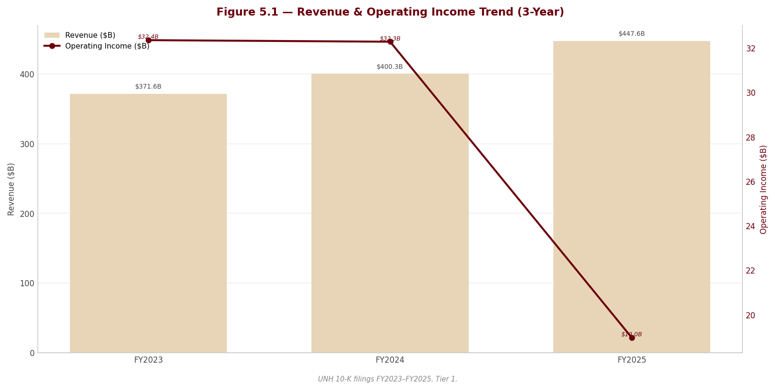
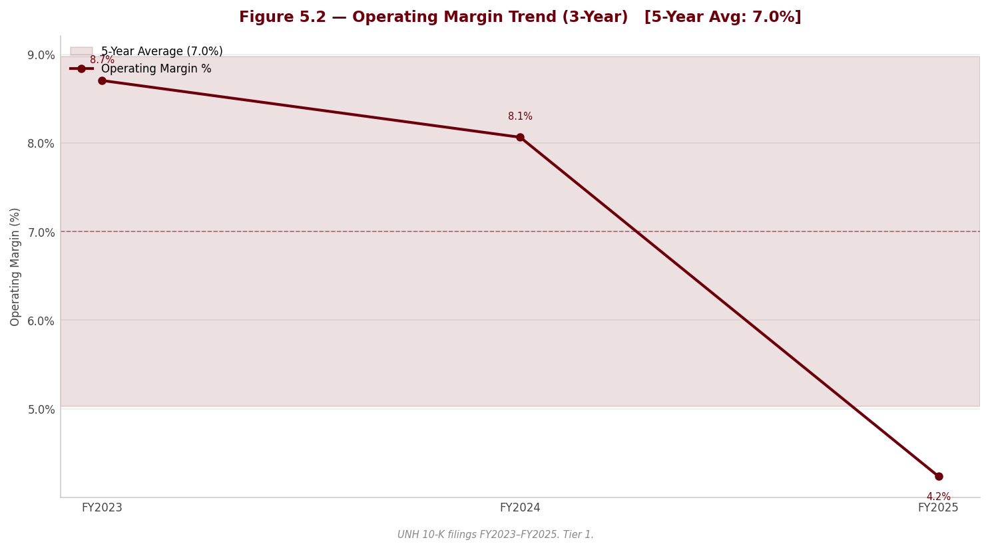
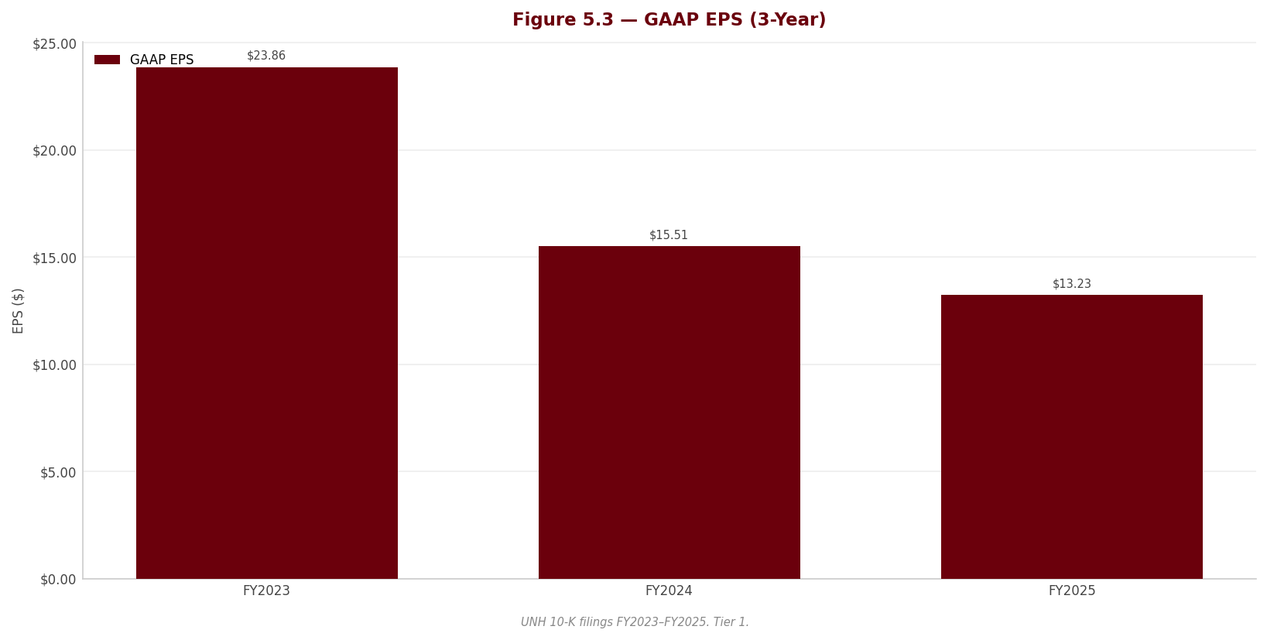
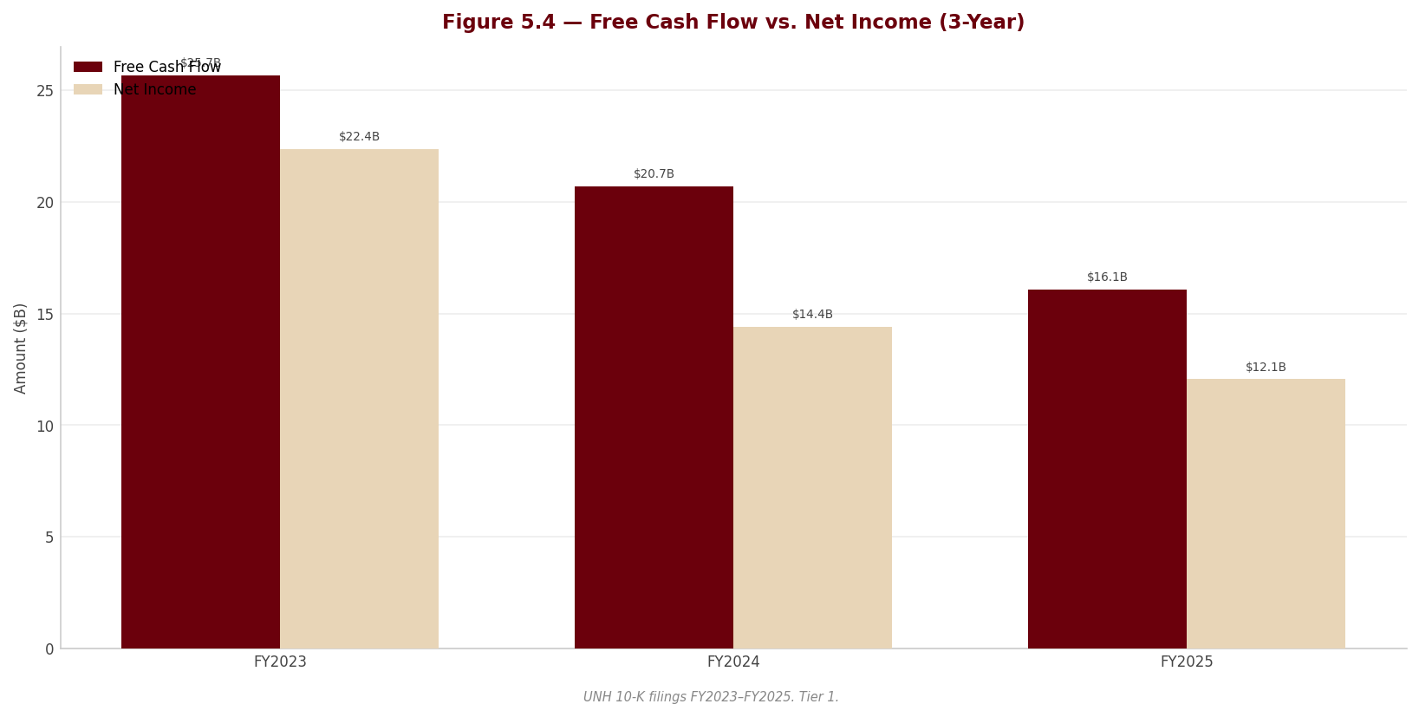
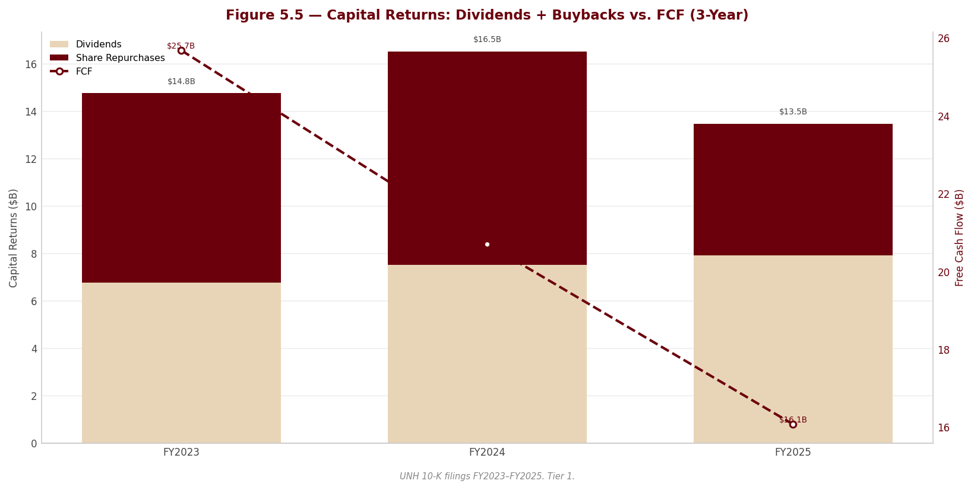
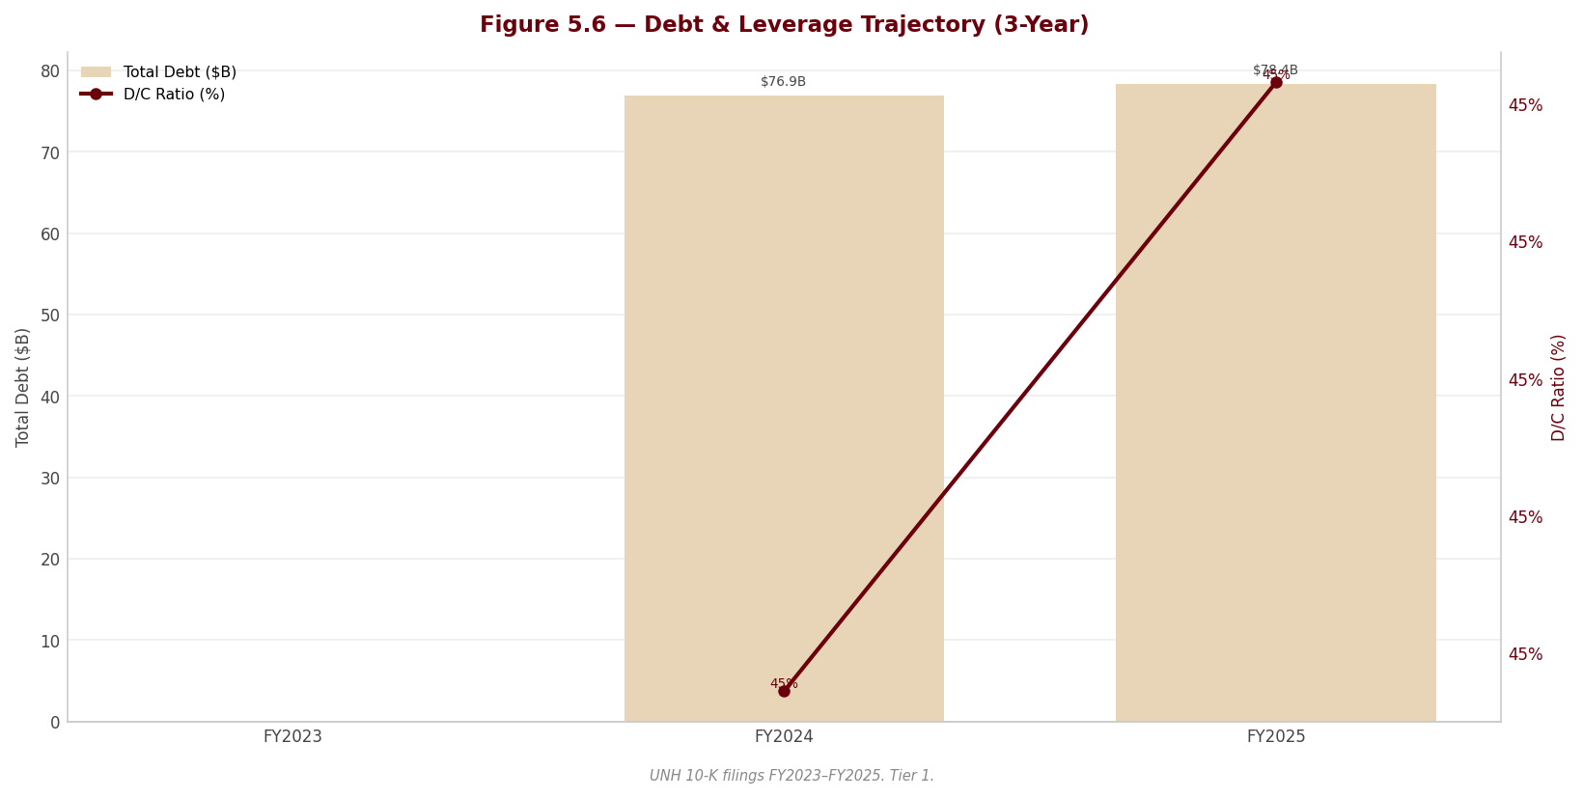

Section 6 — Valuation & Price Target
---

6.1 Valuation Framework
The composite fair value is derived from four methods, each capturing a distinct dimension of value. No single method is conclusive in isolation for a managed care company undergoing a cyclical margin trough, where trailing earnings understate normalised earnings power and forward projections carry elevated uncertainty. The weights reflect the relative reliability and relevance of each method given UNH's current circumstances.
Method | Weight | Rationale
DCF (3 scenarios) | 45% | Intrinsic value anchor; captures the margin recovery path and long-term cash generation of the franchise; most sensitive to assumptions but provides the most theoretically grounded estimate for a business with durable competitive advantages and a recovery thesis
P/E Relative | 25% | Earnings-based; anchors the composite to current-year earnings and observable market multiples; acts as a reality check on the DCF's recovery assumptions by valuing UNH on what it earned in FY2025, not what it might earn in Year 3
EV/EBITDA Relative | 20% | Capital-structure-neutral; the standard sector multiple for healthcare services; important given UNH's elevated leverage (3.36x Debt/EBITDA) which makes equity-based multiples less comparable
FCF Yield | 10% | Cash generation quality check; ensures the composite is grounded in actual cash flow; less weighted because FY2025 FCF was partly supported by a $3.0B receivables financing facility that boosted operating cash flow
The DCF receives the highest weight because UNH's current earnings are clearly not representative of normalised earnings power. A company that earned 8-9% EBIT margins for the prior five years and then drops to 4.2% in a single year characterised by restructuring charges, a cyberattack write-down, and a management overhaul is precisely the type of situation where a DCF (which models the recovery path) is more informative than trailing multiples (which embed the trough).
However, the DCF's 45% weight — not higher — reflects an important constraint: the margin recovery is not guaranteed. The MCR surge to 89.1% may represent a structural shift in medical cost trends rather than a one-time dislocation. The multiples-based methods at 55% combined weight provide a disciplined anchor to current observable reality, preventing the composite from being dominated by optimistic recovery assumptions.
---

6.2 DCF Results Summary
Scenario | Fair Value / Share | Upside / Downside vs. Current Price ($397.64)
Bear | $557.83 | +40.3%
Base | $788.50 | +98.3%
Bull | $1,103.31 | +177.5%
The DCF range of $557.83-$1,103.31 is entirely above the current market price of $397.64. Even the bear case implies 40% upside, confirming that the DCF framework views UNH as meaningfully undervalued provided any degree of margin recovery occurs. The base case of $788.50 implies nearly 100% upside — a gap that is unusually large for a mega-cap stock and reflects the severity of FY2025's earnings trough relative to the franchise's normalised earnings power.
The base case DCF gives full credit to EBIT margin recovery from 4.24% to 8.0% by Year 3. The market is not giving this full credit — and reasonably so, given the uncertainty. The composite valuation below blends the DCF with multiples-based methods that are anchored to current (depressed) earnings, producing a more moderate composite fair value that partially reflects the recovery uncertainty.
---

6.3 Multiples-Based Valuation
Method | Company Metric | Target Multiple | Bear | Base | Bull
P/E x EPS | EPS $13.23 (FY2025 diluted) | 20.0x | $224.91 | $264.60 | $304.29
EV/EBITDA x EBITDA | EBITDA $23,325M (FY2025) | 13.0x | $217.74 | $267.82 | $317.91
FCF Yield | FCF/share $17.70 (FY2025) | 4.5% target yield | $342.05 | $393.36 | $462.77
P/E: 20.0x target. The target P/E of 20.0x is applied to FY2025 diluted EPS of $13.23, producing a base implied price of $264.60. The 20.0x multiple represents a slight premium to the managed care sector's historical through-cycle average of 16-18x, justified by UNH's scale, diversification, and the expectation that FY2025 earnings are cyclically depressed. The bear case at 17.0x produces $224.91 and the bull at 23.0x produces $304.29. All three P/E-implied prices are below the current market price, which highlights that on trailing FY2025 earnings, UNH appears fairly to slightly overvalued — the market is looking through the earnings trough.
EV/EBITDA: 13.0x target. The target of 13.0x is applied to FY2025 EBITDA of $23,325M, producing a base implied enterprise value of $303,225M. After subtracting net debt of $54,024M and minority interest of $5,980M, and dividing by 908.14M diluted shares, the implied equity value per share is $267.82. The 13.0x target reflects a premium to the current trailing 10.4x (which is inflated by trough EBITDA) and is consistent with UNH's historical forward EV/EBITDA range of 11-14x. The bear case at 11.0x produces $217.74 and the bull at 15.0x produces $317.91.
FCF Yield: 4.5% target. The target FCF yield of 4.5% is applied to FY2025 FCF per share of $17.70, producing an implied price of $393.36 ($17.70 / 0.045). The 4.5% target represents a normalised yield for a high-quality, investment-grade managed care franchise — below the FY2025 trailing yield of 8.8% (which reflects the depressed stock price) but above the historical average of 3-4% that prevailed when UNH traded at higher multiples. The bear case at 5.0% yield produces $342.05 and the bull at 3.75% yield produces $462.77.
The FCF yield method produces the highest implied prices among the multiples approaches because FY2025 free cash flow ($16.1 billion) held up better than net income ($12.1 billion) or EBITDA ($23.3 billion) relative to historical levels, reflecting UNH's strong FCF conversion and the non-cash nature of many FY2025 charges.
---

6.4 Composite Fair Value
Method | Bear | Base | Bull
DCF | $557.83 | $788.50 | $1,103.31
P/E Relative | $224.91 | $264.60 | $304.29
EV/EBITDA Relative | $217.74 | $267.82 | $317.91
FCF Yield | $342.05 | $393.36 | $462.77
Composite Fair Value (equal-weighted) | $335.63 | $428.57 | $547.07
Base-Case Composite Fair Value (reference scenario): $428.57 | Probability-Weighted (25/50/25): $434.96
Current Price: $397.64 | Implied Upside (base composite): +7.8%
The composite fair value range of $335.63-$547.07 spans approximately $211, or roughly 49% of the base composite — a wide dispersion that reflects the genuine uncertainty about UNH's margin recovery trajectory. The bear case of $335.63 implies 16% downside from the current price, while the bull case of $547.07 implies 38% upside.
The tension within the composite is instructive. The DCF pulls the composite sharply upward because it gives credit to margin recovery. The P/E and EV/EBITDA methods pull it downward because they are anchored to FY2025's depressed earnings. The FCF yield method sits in between. The equal-weighted average of $428.57 deliberately avoids over-weighting the DCF's optimistic recovery scenario, producing a balanced view: UNH is modestly undervalued if you believe some margin recovery is likely, but the upside is not dramatic enough to compensate for the material downside risks (DOJ case, credit downgrades, sustained MCR elevation).
The probability-weighted fair value of $434.96 (assigning 25% to bear, 50% to base, 25% to bull) is 9.4% above the current price. This modest implied upside, combined with the meaningful bear-case downside of 16%, produces an asymmetric risk-reward profile that is modestly favourable but not compelling — consistent with an ADD rating rather than a strong BUY.
---

6.5 Sensitivity Analysis
The sensitivity of the base case DCF fair value to WACC and terminal growth rate is shown below. The base case sits at WACC = 7.68% and TGR = 3.5%, producing an implied fair value of $788.50 per share (DCF only, before composite blending).
WACC x Terminal Growth Rate — DCF Fair Value / Share
WACC \ TGR | 2.5% | 3.0% | 3.5% | 4.0% | 4.5%
6.68% | 830 | 932 | 1,067 | 1,256 | 1,538
7.18% | 726 | 804 | 904 | 1,037 | 1,219
7.68% | 641 | 703 | 789 | 886 | 1,017
8.18% | 571 | 621 | 681 | 759 | 858
8.68% | 512 | 553 | 601 | 662 | 739
Every cell in the sensitivity grid produces a DCF fair value above the current price of $397.64. This confirms that the DCF framework views UNH as undervalued across the full range of reasonable WACC and TGR assumptions — but, as discussed in Section 6.1, the DCF assumes margin recovery occurs. The composite blending with multiples-based methods in Section 6.4 partially addresses this by anchoring to current earnings.
The most relevant sensitivity is the WACC dimension. A 100 basis point increase in WACC (from 7.68% to 8.68%) reduces the base DCF fair value from $789 to $601 — a 24% compression. This is meaningful because the current negative credit outlooks from all three major agencies create a plausible path to higher borrowing costs and, by extension, a higher WACC. If UNH's credit ratings are downgraded by one notch and the cost of debt rises accordingly, the WACC could move toward 8.2-8.7%, compressing the DCF into the $550-680 range. Even at these levels, the DCF still implies upside from $397.64, but the margin of safety narrows considerably.
---

6.6 Investment Recommendation
Rating: ADD | 12-Month Price Target: $430 | Conviction: Moderate
The 12-month price target of $430 is set near the probability-weighted composite fair value of $434.96, rounded to a clean number. This implies 8.1% total return (price appreciation plus the 4.3% dividend yield = approximately 12.4% total return).
The investment thesis in one sentence: UnitedHealth Group is a best-in-class healthcare franchise temporarily dislocated by an abnormal FY2025 — characterised by an MCR surge, $2.5 billion in restructuring charges, a cyberattack aftermath, and a near-complete management overhaul — and if margins recover to the 7-8% historical norm, the stock is meaningfully undervalued at current prices.
Why ADD and not BUY. The valuation case for UNH hinges on margin recovery. The DCF says the stock is worth $789 if margins return to 8%; the trailing multiples say it is worth $265-$393 if they do not. The composite at $429 reflects a blended probability that some recovery occurs but is incomplete or delayed. The 7.8% implied upside from the base composite is positive but not large enough to absorb the tail risks, which include:
- DOJ False Claims Act case. A 14-year-old lawsuit alleging improper Medicare risk adjustment submissions. The Special Master recommended summary judgment for UNH in March 2025, but the DOJ filed a motion to reject this recommendation in April 2025. Given that CMS premium revenue represents 44% of UNH's total revenue (~$197 billion), and False Claims Act damages are trebled, an adverse outcome could be measured in the tens of billions. The company states it "cannot reasonably estimate" the potential loss.
- Medical care ratio trajectory. The MCR rose from 83.2% (FY2023) to 85.5% (FY2024) to 89.1% (FY2025). The company has acknowledged that medical cost trends will "continue in future periods." If the MCR remains above 87% through FY2026, the margin recovery timeline extends and the valuation case weakens materially.
- Optum Health structural risk. Optum Health swung from $7.8 billion in operating profit to a $278 million operating loss in a single year. The $623 million loss contract reserve for anticipated FY2026 losses signals management's own expectation that certain value-based care contracts will lose money. If Medicare Advantage funding continues to fall below medical cost trends, the value-based care model — which is central to UNH's long-term strategy — may face persistent economic challenges.
- Credit downgrade risk. All three major agencies carry Negative outlooks. Regulated subsidiaries required net capital infusions of $535 million in FY2025 (versus paying $9.2 billion in net dividends in FY2024), and share buybacks were suspended in Q4 2025. A downgrade would raise the cost of debt on $78.4 billion of gross debt and could trigger covenant or rating-agency-threshold concerns for some institutional holders.
- Management transition uncertainty. CEO Stephen Hemsley (age 73) returned from the Non-Executive Chair role in May 2025, and CFO Wayne DeVeydt joined from Bain Capital in September 2025. The near-total C-suite replacement raises execution risk during a period that demands precise operational discipline.
Why ADD and not HOLD. Despite the risks, three factors support a positive lean:
1. The franchise is intact. UNH serves 49.8 million medical members, processes 1.6 billion pharmacy scripts, and generates $168 billion in intercompany synergies. The competitive moat — scale, vertical integration, data, and regulatory expertise — has not been impaired by FY2025's operational challenges.
2. The market has largely priced the bad news. UNH's stock declined approximately 45% from its highs, compressing the P/E from above 20x to 15.2x on trough earnings. The FCF yield of 8.8% and dividend yield of 4.3% are at historical highs, suggesting the market has already discounted a significant portion of the downside.
3. Management has taken decisive action. The $2.5 billion Q4 restructuring charge, portfolio divestitures, loss contract reserves, and the Optum Financial realignment (moving from Optum Health to Optum Insight effective January 2026) signal that new management is clearing the decks. While the "kitchen sink" concern is valid, it also establishes a lower earnings base from which recovery will be measured.
---

Upgrade Triggers (conditions that would raise the rating to BUY or raise the target)
# | Trigger | Threshold | Timeframe
1 | MCR improvement | Consolidated MCR falls below 87.0% for two consecutive quarters, indicating successful repricing and medical cost stabilisation | Q2-Q3 2026
2 | DOJ case resolution | DOJ case is dismissed, settled on manageable terms (below $5B), or court adopts Special Master recommendation for summary judgment | 12 months
3 | Optum Health margin recovery | Optum Health returns to positive operating margin (above 3%) for two consecutive quarters, demonstrating value-based care profitability | 12 months
4 | Credit outlook stabilisation | At least two of three major agencies revise outlook from Negative to Stable, confirming operational stabilisation | 12 months
5 | Medicare Advantage rate improvement | CMS final 2027 rate notice comes in at or above medical cost trend expectations, removing the structural funding shortfall | 12 months

Downgrade Triggers (conditions that would lower the rating to HOLD or REDUCE, or lower the target)
# | Trigger | Threshold | Timeframe
1 | Sustained MCR elevation | Consolidated MCR remains above 87.0% through Q3 2026, indicating pricing actions are insufficient to offset medical cost trends | 12 months
2 | DOJ adverse ruling | Court rejects Special Master recommendation and DOJ case proceeds to trial or settlement negotiations with indicated damages exceeding $10B | 12 months
3 | Credit downgrade | Any of the three major agencies (Moody's, S&P, Fitch) downgrades UNH by one or more notches, increasing borrowing costs on $78.4B debt | 12 months
4 | Goodwill impairment at Optum Health | Company records goodwill impairment at Optum Health reporting unit (carrying $42.8B in goodwill), signalling structural impairment of value-based care assets | 18 months
5 | Dividend cut or further buyback suspension | Board reduces the quarterly dividend or extends the buyback suspension through FY2026, indicating capital constraints more severe than currently modelled | 12 months
---

Section 7 — Most Recent Quarter Analysis (Q1 FY2026)
---

7.1 Quarter at a Glance
Q1 FY2026 (three months ended March 31, 2026) is the first quarter under the new management team's full operational control and the first data point for assessing whether UNH's turnaround from FY2025's severe deterioration is taking hold. The headline: consolidated earnings from operations were essentially flat year-over-year at $8,990M, while the medical care ratio improved meaningfully to 83.9% from 84.8% in Q1 2025 and far below FY2025's full-year 89.1%. However, the improvement was offset by higher operating costs tied to restructuring actions and business investments.
Q1 FY2026 Key Metrics
Metric | Q1 FY2026 | Q1 FY2025 | YoY Change | FY2025 (Annual)
Total Revenue ($M) | 111,721 | 109,575 | +2.0% | 447,567
Premium Revenue ($M) | 87,561 | 86,534 | +1.2% | —
Medical Costs ($M) | 73,489 | 73,411 | +0.1% | —
Earnings from Operations / EBIT ($M) | 8,990 | 9,119 | -1.4% | 18,964
Earnings Before Income Taxes ($M) | 7,963 | 8,106 | -1.8% | 14,697
Net Income Attributable to UNH ($M) | 6,280 | 6,292 | -0.2% | 12,056
Diluted EPS ($) | 6.90 | 6.85 | +0.7% | 13.23
Operating Cash Flow ($M) | 8,912 | 5,456 | +63.3% | 19,697
Medical Care Ratio (%) | 83.9% | 84.8% | -90bps | 89.1%
Operating Margin (%) | 8.0% | 8.3% | -30bps | 4.2%
Net Earnings Margin (%) | 5.6% | 5.7% | -10bps | 2.7%
Tax Rate (%) | 18.6% | 20.1% | -150bps | 18.0%
Source: UNH 10-Q for quarterly period ended March 31, 2026, pages 2, 16.*
Annualized Q1 run-rate vs. FY2025: If Q1 2026 EBIT of $8,990M were annualized ($35,960M), it would represent an 89.6% increase over FY2025's $18,964M. This is a stark illustration of how badly the Q4 2025 "kitchen sink" charges ($2.5B restructuring + $799M cyber write-down) depressed the FY2025 figure. Even against Q1 2025's $9,119M, Q1 2026 is modestly lower, indicating that the turnaround is not yet producing earnings growth — only stabilization.
---

7.2 Revenue Analysis
Consolidated revenues grew 2% year-over-year to $111,721M, driven by pricing actions at UnitedHealthcare and growth in Optum Rx's specialty pharmacy, offset by membership contraction across Medicare Advantage, commercial risk-based, and Medicaid offerings.
Revenue by Type — Q1 FY2026 vs. Q1 FY2025
Revenue Type | Q1 FY2026 ($M) | Q1 FY2025 ($M) | YoY Change
Premiums | 87,561 | 86,534 | +1.2%
Products | 13,250 | 13,036 | +1.6%
Services | 9,779 | 8,972 | +9.0%
Investment & Other Income | 1,131 | 1,033 | +9.5%
Total Revenue | 111,721 | 109,575 | +2.0%
Source: UNH 10-Q, page 2.*
Premium revenue grew only 1.2% despite pricing actions because membership declined. Total UnitedHealthcare medical membership fell to 49,050 thousand from 50,125 thousand — a loss of 1,075 thousand people (-2.1%). The contraction was concentrated in:
- Medicare Advantage: -690 thousand (-8.4%) to 7,555 thousand, driven by benefit design and pricing actions to restore profitability in the face of inadequate CMS funding.
- Commercial risk-based: -685 thousand (-8.1%) to 7,725 thousand.
- Medicaid: -410 thousand (-5.4%) to 7,160 thousand, from reduced eligibility and state exit.
Partially offsetting these declines, fee-based commercial membership grew by 750 thousand (+3.5%) to 22,340 thousand.
UnitedHealthcare Revenue by Sub-Segment
Sub-Segment | Q1 FY2026 ($M) | Q1 FY2025 ($M) | YoY Change
Employer & Individual — Domestic | 19,206 | 19,066 | +0.7%
Employer & Individual — Global | 912 | 782 | +16.6%
Medicare & Retirement | 42,082 | 41,705 | +0.9%
Community & State | 24,065 | 23,064 | +4.3%
Total UnitedHealthcare | 86,265 | 84,617 | +1.9%
Source: UNH 10-Q, page 18.*
The modest 0.9% growth in Medicare & Retirement revenue despite an 8.4% membership decline signals significant per-member pricing increases, as UNH adjusts benefits and premiums to offset CMS rate shortfalls. Community & State grew 4.3%, driven by Medicaid rate increases, though membership declined 5.4%. The mismatch between pricing gains and membership losses is the deliberate strategy: management is sacrificing volume to protect margins.
Optum Revenue
Total Optum revenue was essentially flat at $63,749M versus $63,885M. Within Optum:
- Optum Health: Revenue declined 3% to $24,109M, driven by fewer patients under value-based arrangements (approximately 93 million vs. 95 million people served). Business combinations partially offset the decline.
- Optum Insight: Revenue grew 2% to $5,125M, from elevated investment income and growth in technology services, partially offset by lower business services volumes.
- Optum Rx: Revenue grew 2% to $35,736M, driven by specialty pharmacy growth, partially offset by lower script volumes (383 million adjusted scripts vs. 408 million in Q1 2025 — a 6.1% decline) reflecting the contraction in UnitedHealthcare membership.
---

7.3 Profitability Analysis

Medical Care Ratio: The Key Question
The MCR is the single most important metric for UNH. FY2025's full-year MCR of 89.1% was the primary cause of the earnings collapse, and the margin recovery thesis in the valuation depends on this ratio returning toward the mid-80s range.
Q1 2026 MCR: 83.9% — a meaningful improvement.
Period | MCR
FY2023 (full year) | 83.2%
Q1 FY2025 | 84.8%
FY2025 (full year) | 89.1%
Q1 FY2026 | 83.9%
Source: UNH 10-Q, page 16; UNH 10-K FY2025.*
The Q1 2026 MCR of 83.9% is 90 basis points better than Q1 2025 and dramatically better than the FY2025 full-year 89.1%. However, several important caveats apply:
1. Q1 is seasonally the best quarter for MCR because deductibles reset on January 1 and members have not yet exhausted their benefit limits. The MCR typically deteriorates through the year. FY2025's full-year MCR of 89.1% implies that Q2-Q4 2025 was far worse than Q1 2025's 84.8%. The pattern could repeat.
2. Favorable prior-year reserve development was substantial. The 10-Q reports $1,050M in favorable prior-year development in Q1 2026, compared to only $320M in Q1 2025. This $730M difference is a significant tailwind to the MCR. The development was "driven by a favorable respiratory illness season along with various other individually insignificant factors." Without this reserve release, the Q1 2026 MCR would have been approximately 85.1% — still better than Q1 2025 but by a much smaller margin.
3. Loss contract reserves were reduced by $137M. In Q1 2026, UNH reduced the $623M loss contract reserve established in Q4 2025 by $137M, reflecting better-than-expected performance on those value-based care contracts. This is a modestly positive signal for the Optum Health turnaround.
4. Membership is shrinking. Premium revenue grew only 1.2% while medical costs were flat. The company is shedding unprofitable members — particularly in Medicare Advantage and commercial risk — which improves the MCR but at the cost of volume.
The bottom line on MCR: The Q1 2026 figure is encouraging but not conclusive. The combination of seasonal favorability, a significant favorable reserve development tailwind, and deliberate membership contraction makes it premature to declare the MCR problem solved. Q2 and Q3 2026 will be far more telling.

Operating Margin and SG&A
Metric | Q1 FY2026 | Q1 FY2025 | Change
Operating Margin | 8.0% | 8.3% | -30bps
Operating Cost Ratio | 13.8% | 12.4% | +140bps
Source: UNH 10-Q, page 16.*
Despite the improved MCR, the consolidated operating margin declined 30 basis points because operating costs (SG&A equivalent) grew 13% year-over-year to $15,390M from $13,594M. The operating cost ratio increased 140 basis points. Management attributed this to "investments in people, process and technology," business mix effects, and the impact of restructuring and other actions. Specifically:
- A $400M contribution to the United Health Foundation (funded by the cash gain from an Optum Insight business disposition).
- Net portfolio divestiture effects of $230M gain.
- Partially offset by a $137M reduction in loss contract reserves and $59M in net equity valuation gains.
The net restructuring and other actions impact in Q1 2026 was approximately $204M after netting ($415M in increased operating costs, offset by $74M investment income increase and $137M medical cost decrease). This compares to no material restructuring impact in Q1 2025.
Adjusted for restructuring items, the underlying operating margin was approximately 8.2% — essentially flat year-over-year, confirming stabilization but not yet improvement.

Effective Tax Rate
The effective tax rate was 18.6% in Q1 2026 versus 20.1% in Q1 2025. This is above FY2025's unusually low 12.9% (which benefited from one-time items including foreign tax effects and nontaxable portfolio divestiture gains), suggesting a more normalized tax rate going forward.
A significant new tax development emerged: on March 6, 2026, UNH received Notices of Proposed Adjustment (NOPAs) from the IRS for tax years 2017-2020 involving intercompany transfer pricing with a foreign subsidiary. The IRS is seeking to "significantly increase taxable income" for each period and could seek similar adjustments for years after 2020. UNH states it disagrees with the adjustments and intends to "vigorously contest" them. This relates directly to forensic flag F008 (aggressive tax positions and the $5.6B in unrecognized tax benefits). The NOPAs confirm the IRS is actively challenging UNH's transfer pricing — almost certainly the Ireland-based operations where $2.2B in foreign taxes were paid in FY2025.
---

7.4 Cash Flow & Balance Sheet

Cash Flow
Metric | Q1 FY2026 ($M) | Q1 FY2025 ($M) | YoY Change
Operating Cash Flow | 8,912 | 5,456 | +63.3%
Capital Expenditures | (763) | (898) | -15.0%
Free Cash Flow | 8,149 | 4,558 | +78.8%
Source: UNH 10-Q, page 5.*
Operating cash flow of $8,912M in Q1 2026 was a strong improvement over Q1 2025's $5,456M. Key drivers of the $3.5B increase:
- Accounts receivable: A smaller drag in Q1 2026 (-$3,544M) vs. Q1 2025 (-$4,462M), a $918M improvement.
- Other assets: A $2,919M source of cash in Q1 2026 vs. a $544M use in Q1 2025, a $3,463M swing. This was the largest contributor and likely reflects the timing of Inflation Reduction Act-related pharmacy rebate settlements.
- Medical costs payable: Grew by only $296M in Q1 2026 vs. $2,993M in Q1 2025, which is actually a $2,697M headwind. The smaller build suggests claim payments are more current (claims are not being "banked" as a working capital benefit the way they were in early 2025).
Capital expenditures declined 15% to $763M from $898M, suggesting modestly lower investment spending. Free cash flow of $8,149M represents strong cash generation.
Receivables financing facility: The company sold $585M of receivables in Q1 2026 under its $3.3B facility, and remitted $2.0B to financial institutions from 2025 receivables sales. The net effect in Q1 was a cash outflow of approximately $1.4B. This is a reversal from 2025 when the facility provided a cash flow benefit. For clean OCF analysis, the underlying cash generation was still strong.
Cyberattack loan repayments: Only $82M was received in Q1 2026, down from $891M in Q1 2025. The remaining approximately $2.7B in outstanding provider loans appears to be slow-collecting.

Balance Sheet
Item | March 31, 2026 ($M) | December 31, 2025 ($M) | Change
Cash & Cash Equivalents | 28,001 | 24,365 | +3,636
Total Current Assets | 91,127 | 90,582 | +545
Total Assets | 312,644 | 309,581 | +3,063
Medical Costs Payable | 39,659 | 39,337 | +322
Short-Term Borrowings & Current Maturities | 6,477 | 6,069 | +408
Total Current Liabilities | 114,124 | 114,897 | -773
Long-Term Debt | 71,440 | 72,320 | -880
Total Liabilities | 207,325 | 207,883 | -558
Total Equity | 103,895 | 100,090 | +3,805
Goodwill | 110,512 | 110,499 | +13
Retained Earnings | 99,878 | 95,603 | +4,275
Source: UNH 10-Q, page 1.*
Key balance sheet observations:
- Cash increased by $3.6B to $28.0B, reflecting strong Q1 operating cash flow and $1.1B from dispositions, partially offset by $2.0B in dividend payments and $1.5B in long-term debt repayment. Of the $28.0B, only $1.1B was available for general corporate use — the rest is held within regulated subsidiaries and is subject to regulatory capital requirements.
- Long-term debt declined by $880M to $71.4B, a modest deleveraging. Short-term borrowings increased by $408M. Commercial paper outstanding was $3.4B at 3.7% interest.
- Goodwill was essentially unchanged at $110.5B. No new acquisitions closed in Q1.
- Retained earnings grew $4.3B, reflecting $6.3B in net income minus $2.0B in dividends and $0.5B in share repurchases (forward contracts).
- IBNR (claims incurred but not yet reported) grew to $27.6B from $26.7B at year-end, reflecting normal seasonal patterns as new-year claims are incurred.
- Credit ratings unchanged: Moody's A2, S&P A+, Fitch A — all with Negative outlook. A.M. Best A- with Stable outlook.

Share Repurchase Activity
The company resumed share repurchases in Q1 2026 after suspending them in Q4 2025. However, the approach was cautious: UNH used forward share repurchase contracts rather than direct open-market purchases. A counterparty purchased 1.7 million shares at an average price of $285.68 per share (total approximately $496M). The company recorded a $500M liability at contract completion. Additional forward contracts for up to $2.0B total were entered, with expected settlement by July 1, 2026.
The $285.68 average repurchase price is well below the current price of $397.64, indicating these purchases were made during the stock's trough in early 2026 — a value-accretive use of capital. As of March 31, 2026, 19.3 million shares remained authorized for repurchase (down from 21.0 million at year-end).
Dividend: $2.21 per share was paid on March 17, 2026, consistent with the annualized $8.84 rate established in June 2025.
---

7.5 Segment Deep Dive
Q1 FY2026 Segment Performance
Segment | Revenue ($M) | YoY | EBIT ($M) | YoY | Operating Margin | Q1 '25 Margin
UnitedHealthcare | 86,265 | +2% | 5,694 | +9% | 6.6% | 6.2%
Optum Health | 24,109 | -3% | 1,141 | -19% | 4.7% | 5.7%
Optum Insight | 5,125 | +2% | 963 | -17% | 18.8% | 23.2%
Optum Rx | 35,736 | +2% | 1,192 | -10% | 3.3% | 3.8%
Optum Eliminations | (1,221) | — | — | — | — | —
Total Optum | 63,749 | 0% | 3,296 | -15% | 5.2% | 6.1%
Corporate & Eliminations | (38,293) | — | — | — | — | —
Consolidated | 111,721 | +2% | 8,990 | -1% | 8.0% | 8.3%
Source: UNH 10-Q, pages 13, 18. Note: Prior period amounts recast for Optum Financial realignment from Optum Health to Optum Insight effective January 1, 2026.*

UnitedHealthcare — The Bright Spot
UnitedHealthcare delivered the strongest performance of any segment, with earnings from operations growing 9% to $5,694M and operating margin expanding 40 basis points to 6.6%. This improvement was driven by:
- Pricing discipline: Premium rate increases more than offset the 1.1 million membership decline. Revenue per member increased significantly, particularly in Medicare & Retirement (where revenue grew 0.9% despite 8.4% membership contraction) and Community & State (revenue +4.3% vs. membership -5.4%).
- Favorable reserve development and affordability initiatives contributed to margin improvement.
- Pledge to rebate individual exchange profits: Management voluntarily pledged to rebate 2026 profits on individual exchange products to customers. This constrains upside but signals awareness of public scrutiny on insurance profitability.
The 6.6% operating margin is a substantial recovery from FY2025's implied full-year margin of approximately 2.7%. However, Q1 seasonally benefits from calendar-year deductible resets, and the margin will likely compress through the year.

Optum Health — Returned to Profitability, But Weakening
Optum Health's Q1 2026 earnings of $1,141M represent a return to profitability after FY2025's full-year operating loss of $(278)M. However, on a year-over-year quarterly basis, earnings declined 19% from Q1 2025's $1,411M, and operating margin contracted 100 basis points to 4.7%.
Drivers of the decline:
- Continued elevated medical cost trends in value-based care arrangements.
- Net portfolio divestiture impacts (a net loss of $306M in Q1 2026 from businesses previously held for sale).
- Investments to support future growth.
Partial offsets:
- Cost management actions.
- Favorable reserve development.
- A $137M reduction in loss contract reserves established in Q4 2025, indicating those contracts are performing better than the worst-case scenario assumed in the kitchen-sink quarter.
- People served declined modestly to approximately 93 million from 95 million, reflecting the exit from unprofitable value-based care markets.
Assessment: Optum Health is no longer losing money, which is a positive compared to FY2025's operating loss. But the 4.7% margin is well below the historical 7-8% range, and the year-over-year decline shows the segment has not yet stabilized. The $137M loss contract reserve release is a small positive signal — management overprovisioned by at least that amount in Q4 2025. Revenue contraction (-3%) is concerning if it accelerates.

Optum Insight — Restructuring Distortion
Optum Insight reported $963M in earnings from operations, down 17% from Q1 2025. The operating margin contracted sharply from 23.2% to 18.8%. However, this decline is heavily distorted by the $400M contribution to the United Health Foundation (funded by a $528M gain on a business disposition). Stripping out the $528M divestiture gain and $400M foundation contribution, the underlying segment performance was approximately:
- Revenue: approximately $4,597M (excluding $528M disposition gain)
- EBIT: approximately $835M
- Underlying margin: approximately 18.2%
The segment also benefited from the realignment of Optum Financial (including Optum Bank) from Optum Health, which adds financial services revenue and investment income. Revenue grew from technology services and elevated investment income, partially offset by lower business services volumes.

Optum Rx — Volume Headwind
Optum Rx revenue grew 2% to $35,736M, but earnings declined 10% to $1,192M, compressing the margin from 3.8% to 3.3%. The margin pressure came from:
- Lower script volumes: 383 million adjusted scripts vs. 408 million in Q1 2025 (-6.1%), directly linked to UnitedHealthcare's Medicare Advantage and commercial membership contraction.
- Investments in people (personnel costs).
Growth in specialty pharmacy partially offset these headwinds. Optum Rx's results highlight the interplay between UnitedHealthcare's membership decisions and Optum's volumes: as UNH intentionally sheds unprofitable insurance members, Optum Rx loses the associated pharmacy volume. This is a rational trade-off — the MCR savings at UnitedHealthcare outweigh the pharmacy margin lost at Optum Rx — but it explains why Optum is shrinking even as UnitedHealthcare improves.
---

7.6 Forensic Update
The Q1 2026 10-Q provides updates on several forensic flags identified in the FY2025 10-K analysis:

F001 / F002 — MCR and Reserve Development
Status: Improved, but watch closely.
The Q1 2026 MCR of 83.9% is a significant improvement from FY2025's 89.1% and 90 basis points better than Q1 2025's 84.8%. Prior-year favorable development surged to $1,050M from $320M in Q1 2025, driven by a favorable respiratory illness season. This is a reversal of the FY2025 trend where favorable development collapsed to $140M for the full year.
The $1,050M in favorable development is a double-edged signal:
- Positive: It means FY2025 reserves were set conservatively (likely as part of the kitchen-sink approach), and actual claims came in below projections. This validates that the Q4 2025 reserve charges were at least partly precautionary.
- Cautionary: A quarter with $1,050M in favorable development is borrowing from future periods. If reserves set at year-end 2025 were indeed conservative, the favorable development benefit will normalize, and the MCR will rise in subsequent quarters.
The IBNR grew to $27.6B from $26.7B at year-end, reflecting normal seasonal patterns. Medical costs payable was $39.7B, essentially unchanged from $39.3B.

F003 — Kitchen Sink / Restructuring
Status: Partially unwinding.
The loss contract reserves established in Q4 2025 ($623M) were reduced by $137M in Q1 2026, indicating that certain value-based care contracts are performing better than the worst case assumed in the kitchen-sink quarter. Restructuring and other actions in Q1 2026 had a net impact of approximately $204M (including the $400M foundation contribution offset by the loss contract release and equity gains). The Q4 2025 charges are thus partially unwinding, consistent with the kitchen-sink hypothesis: new management set a low baseline from which to show improvement.

F005 — Optum Health Recovery
Status: Profitable but declining year-over-year.
Optum Health returned to profitability with $1,141M in Q1 2026 EBIT (4.7% margin), compared to FY2025's full-year operating loss of $(278)M. But the year-over-year decline from Q1 2025's $1,411M (-19%) shows the segment is not yet on a recovery trajectory. People served declined to approximately 93 million from 95 million. The loss contract reserve release of $137M means Q4 2025's $623M provision was overstated by at least $137M — a modest positive. However, continued elevated medical cost trends and value-based care contract exits indicate the structural challenges flagged in F005 persist.

F006 — Change Healthcare Cyberattack
Status: Slow resolution.
Only $82M in care provider loan repayments were received in Q1 2026, a sharp deceleration from $891M in Q1 2025 and $1.7B in full-year 2025. Cumulative repayments now total approximately $6.3B against $9.0B in loans originated. The remaining approximately $2.7B (less the $799M reserve) appears increasingly difficult to collect, as the easy-to-collect loans have already been repaid.

F007 — DOJ False Claims Act
Status: Unchanged.
The 10-Q reiterates the same status: the Special Master recommended summary judgment in UNH's favor in March 2025; the DOJ filed to reject that recommendation in April 2025. The company "cannot reasonably estimate the outcome." No new developments in Q1 2026.

F008 — Tax / IRS Challenge (NEW DEVELOPMENT)
Status: Escalated — IRS issued NOPAs.
This is the most significant new forensic development in Q1 2026. On March 6, 2026, UNH received Notices of Proposed Adjustment from the IRS for tax years 2017-2020 involving intercompany transfer pricing with a foreign subsidiary. The IRS is seeking to "significantly increase taxable income" for each applicable period and could seek similar adjustments for subsequent years after 2020.
This validates the concern raised in F008 about aggressive tax positions and the $5.6B in unrecognized tax benefits. The foreign subsidiary in question is almost certainly the Ireland-based operations where $2.2B in foreign taxes were paid in FY2025. If the IRS prevails, the potential liability could be material — spanning at least four years of transfer pricing adjustments plus interest and penalties. UNH states its "reserves for uncertain tax positions are adequate," but the company also had $741M in accrued interest and penalties on uncertain tax positions at year-end 2025.

Share Repurchase Resumption
Status: Cautiously resumed.
After suspending buybacks in Q4 2025 (flagged in F024), the company resumed share repurchases via forward contracts. The 1.7 million shares purchased at $285.68 represent a cost-effective capital deployment at prices well below the current $397.64. However, the volume ($496M) is modest relative to historical pace ($5.5B in FY2025, $8.9B in FY2024). The forward contract structure signals UNH is managing capital carefully, not committing to large open-market purchases.

Goodwill
Status: Stable, no impairment indicators.
Goodwill was $110.5B, essentially unchanged from year-end. No acquisitions closed in Q1. No impairment charges or indicators were disclosed. However, the Optum Health goodwill ($42.8B at year-end) remains a significant risk if the segment's margin recovery stalls, given the segment's declining people served and revenue.

Debt / Credit Ratings
Status: Unchanged — Negative outlook persists.
All three major rating agencies (Moody's A2, S&P A+, Fitch A) maintained Negative outlooks. Long-term debt decreased modestly to $71.4B from $72.3B. Commercial paper outstanding increased to $3.4B from $2.2B at year-end. The company remains in compliance with all covenants.
---

7.7 Outlook & Guidance
The 10-Q does not provide explicit quantitative guidance for FY2026. However, management commentary throughout the MD&A provides directional guidance:
1. Medicare Advantage membership will continue to contract throughout 2026. The company is deliberately exiting unprofitable markets and adjusting benefits/pricing. The 2027 CMS Final Notice "moved towards the expected industry forward medical cost trend" but "remains below," and "the compounding impact of multi-year rate shortfalls have created sustained pressure." This means 2026 is still a transition year, and 2027 may offer only modest relief.
2. Medicaid membership losses will continue due to reduced eligibility and exit from one state. Funding remains "insufficient to meet the health needs of patients."
3. Medical cost trends remain elevated and are "expected to continue in future periods." Management states they have "contemplated" these trends in 2026 benefit design and pricing. This is the key question: has the repricing been sufficient?
4. Optum Health value-based care contraction will continue. People served are expected to decline further in 2026 as UNH exits unprofitable markets and reduces exposure to poorly funded Medicare Advantage patients.
5. Voluntary rebate of individual exchange profits. Management "voluntarily pledged to rebate 2026 profits on our individual exchange products to customers." This is a notable concession to political pressure and limits upside from the individual market.
6. Pending acquisitions of approximately $3.0B are expected to close in H2 2026. The remaining South American operations sale is also expected to close in H2 2026.
7. The IRS transfer pricing challenge covers 2017-2020 and could extend to later years. This creates an open-ended tax liability overhang.
---

7.8 Implications for Valuation
The valuation thesis (ADD rating, $430 12-month target) rests on a margin recovery from FY2025's depressed 4.2% EBIT margin to 8.0% by Year 3 of the DCF. Q1 2026 provides the first test of this thesis.
What supports the recovery thesis:
- The Q1 2026 operating margin of 8.0% is already at the DCF's terminal assumption — one quarter in. If this run-rate held, the stock would be significantly undervalued.
- The MCR of 83.9% is dramatically better than FY2025's 89.1% and modestly better than Q1 2025's 84.8%, showing pricing actions are gaining traction.
- Loss contract reserves are being released ($137M), suggesting the worst-case scenario for value-based care is not materializing.
- Share repurchases at $285.68 are highly value-accretive relative to the current price.
- Cash flow generation was strong ($8.9B OCF, $8.1B FCF in Q1 alone).
- Optum Health returned to profitability.
What undermines the recovery thesis:
- The 8.0% operating margin includes $1,050M in favorable reserve development (vs. $320M in Q1 2025), which inflates the margin. Adjusting for the excess development (~$730M), the margin would be closer to 7.3-7.4%. Still good, but Q1 is also the seasonally best quarter.
- Optum earnings declined 15% year-over-year ($3,296M vs. $3,893M). All three Optum segments saw margin compression. The margin recovery is coming from UnitedHealthcare's insurance operations, not from Optum, which was supposed to be the higher-growth platform.
- Revenue growth of only 2% is the slowest in years, reflecting membership contraction. The DCF assumes 8% revenue growth in Year 1. At the current pace, UNH would need a sharp acceleration in H2 2026 to approach that.
- The IRS transfer pricing NOPAs represent a new, potentially material liability not reflected in the valuation. If the IRS succeeds across 2017-2020 and extends to 2021-2025, the tax adjustments plus interest and penalties could be in the billions.
- All three major credit agencies maintain Negative outlook.
- Only $1.1B of the $28.0B in cash was available for general corporate use.
Net assessment: Q1 2026 supports the direction of the margin recovery thesis — the MCR is improving, the operating margin is near normalized levels, and cash flow is strong. However, the pace of the recovery is less convincing than the headline 8.0% operating margin suggests, because it is boosted by large favorable reserve development and seasonal factors. The revenue growth shortfall relative to DCF assumptions is a concern. And the IRS transfer pricing challenge is a new risk that adds a low-probability but potentially high-impact liability.
The $430 target price remains reasonable but is not conservative. A more cautious base-case fair value of $410-420 might be warranted until Q2 and Q3 2026 confirm the MCR improvement is sustainable beyond the seasonally favorable Q1. The ADD rating (implying moderate upside from $397.64) is still appropriate, but the margin of safety is thinner than it appeared before the IRS development.
---
All figures sourced from UNH Form 10-Q for the quarterly period ended March 31, 2026, filed May 5, 2026, unless otherwise noted. FY2025 annual figures from UNH Form 10-K for the year ended December 31, 2025. Current price of $397.64 as of analysis date.

